**Spellings**

Spellings will be given out on a Friday and a spelling test will be completed the following Friday.

**Homework**

A massive WELL DONE to Robins for creating some fantastic pieces of homework, I was extremely impressed.

I will be handing out this terms homework grid on Friday 1st November. This grid will consist of tasks and activities that are linked to the topics that we are learning this term.

Each topic will be worth house points and it is up to you and your child how many you complete over the forthcoming weeks. Tasks can either be handed in weekly or as a whole at the end of the term.

I am thoroughly looking forward to see all your hard work.

**Have fun Robins**!

**PE**

Monday Afternoon- Gym

Friday Morning- Bench ball

Please ensure full PE kit is in school at all times.

**Welcome Back Robins Class!**

Welcome to Term 2, I hope you all had a lovely break and are ready for another fun packed term.

I want to say a massive well done to all of the children who worked extremely hard last term. They have all settled in brilliantly and I am very excited to see some more amazing work this Christmas term.

If you have any questions or queries please feel free to come and see me.

**Parents Evening**

Parents evening will be taking place on the 26th and 27th of November.

**Ks1 Nativity**

The key stage 1 nativity will be performed to parents on Thursday 12th December at 2pm. We look forward to wowing you with our performance.

**Reading Books**

Reading books will be changed daily if needed. Every morning I will check your child’s home reading log. Please make sure you keep these updated as I will not change their books unless an adult has written that they finished them at home.

Your child will read every day during our DEAR (drop everything and read) time. This is when the children have time to read their reading books independently.

I will try my hardest to make sure I hear your children read at least once a week.

Please try and read at home with your child when possible.

**All the best**

**Miss Harney**

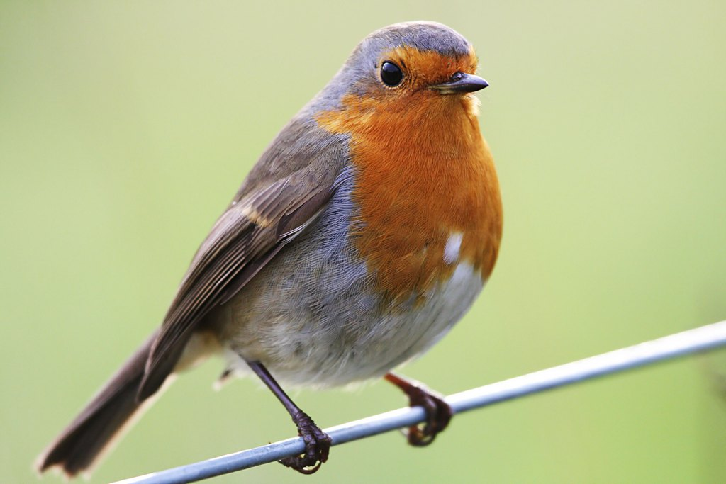

**Topic!**

Our Big Question this term is

Do you have to be good to be remembered?

Therefore Robins will be learning all about two very important figures in our English history, Guy Fawkes and Florence Nightingale.

I am sure the children will be excited to tell you all about them.

**Maths!**

This term we will be learning about addition and subtraction which will be followed by geometry.

**Science!**

Our Big Idea in Science this term is ‘The natural world outside changes at different times in a year’. I am positive we will lots of fun investigating the changes in our outdoor environment.