**Spellings**

As you probably realised, I did not give spellings out last term and this was due to the fact that the children had their lines to learn. I will be handing out spellings as normal this term.

**Reading Books**

Reading books will be changed daily if needed. Every morning I will check your child’s home reading log. Please make sure you keep these updated as I will not change their books unless an adult has written that they finished them at home.

Your child will read every day during our DEAR (drop everything and read) time. This is when the children have time to read their reading books independently.

I will try my hardest to make sure I hear your children read at least once a week.

Please try and read at home with your child when possible.

**PE**

Monday Afternoon- Dance

Friday Afternoon- Multi skills

Please ensure full PE kit is in school at all times.

**Welcome Back Robins Class!**

I hope you all had a lovely Christmas and I would like to wish you all a happy new year! Thank you so much for my Christmas cards and presents, it was extremely thoughtful and kind.

The children had an extremely busy term 2 due to our class assembly and nativity but they did so well and worked very hard. It was so lovely seeing you all at our performances and thank you to those parents who bought in costumes.

Here is some information about this term.

**Homework**

I was so impressed with the homework I received last term! I can see Robins have been working very hard at home with your support. Some of our Robins created some truly fantastic models of Florence Nightingales hospital, please come and see them.

I will be handing out this terms homework grid on Friday 11th January. This grid will consist of tasks and activities that are linked to the topics that we are learning this term.

Each topic will be worth house points and it is up to you and your child how many you complete over the forthcoming weeks. Tasks can either be handed in weekly or as a whole at the end of the term.

**Have fun Robins**!

**Parents Evening**

It was lovely seeing you all at Parents Evening last term. If you have issues throughout the term please feel free to come and see me.

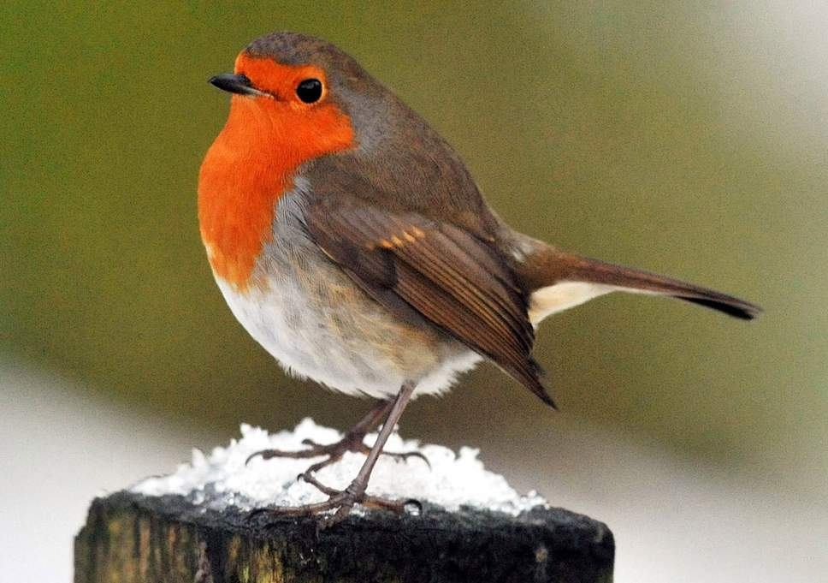

**All the best**

**Miss Harney**

**Ash Cartwright and Kelsey**

**Topic!**

Our topic this term is

Castles, Kings and Queens.

Robins will be travelling back in time this term, learning all about ancient castles and fabulous Monarchs from our past.

I am sure we will have lots of fun!

**Maths!**

This term we will be learning about addition and subtraction within 20 and place value up to 50.

**Science!**

Our Big Idea in Science this term is ‘There are lots of animals and there are ways of grouping them’. Make sure you ask your child about all the different groups and animals they have learnt about.