**Medication**

If your child needs to take any medication please visit the office and fill in a medication form.

**Our Class Assembly**

Robins class assembly will be taking place on Friday 9th November.

**Reading Books**

Reading books will be changed daily if needed. Every morning I will check your child’s home reading log. Please make sure you keep these updated as I will not change their books unless an adult has written that they finished them at home.

Your child will read every day during our DEAR (drop everything and read) time. This is when the children have time to read their reading books independently.

I will try my hardest to make sure I hear your children read at least once a week.

Please try and read at home with your child when possible.

**All the best**

**Miss Harney**

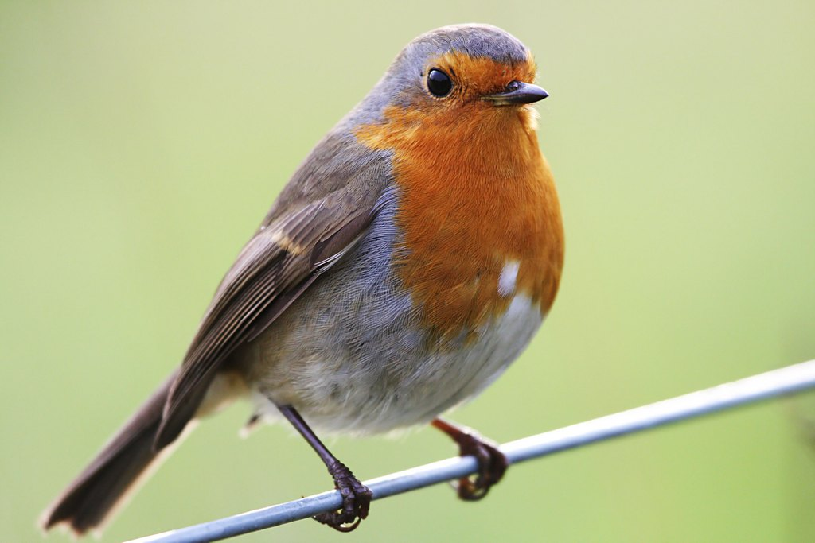

**PE**

Monday Afternoon- Gymnastics

Friday Afternoon- Multiskills

Please ensure full PE kit is in school at all times.

**Welcome To Robins Class!**

I hope you all had a fun packed holiday and enjoyed the beautiful weather.

For those who haven’t met me yet I am Miss Harney. Last year I was the class teacher of Magpies but this year I will be with your child in The Amazing Robins Class.

I am very excited about the following school year and cannot wait to get to know you and your child!

If you have any questions or queries please feel free to come and see me.

**Topic!**

Our topic this term is

Book Worms!

Robins will be reading and exploring some excellent stories this term including The Three Little Pigs and Little Red Riding Hood.

Make sure you ask your child about their learning and see if they can retell you these fabulous stories.

**Maths!**

This term we will be learning about place value which will be followed by addition and subtraction.

**Science!**

Our Big Idea in Science this term is ‘There are many types of materials and they each have their own properties (things that they can do)’. I am positive we will lots of fun investigating this idea.

**Homework**

I will be handing out this terms homework grid on Friday 14th September. This grid will consist of tasks and activities that are linked to the topics that we are learning this term.

Each topic will be worth house points and it is up to you and your child how many you complete over the forthcoming weeks. Tasks can either be handed in weekly or as a whole at the end of the term.

I am thoroughly looking forward to see all your hard work.

**Have fun Robins**!

**Spellings**

Spellings will be given out on a Friday and a spelling test will be completed the following Friday.