 | ASH CARTWRIGHT & KELSEY  Church of England (AIDED) Primary School  Through God’s love and strength all flourish  Our Christian vision guides our journey to provide a rich, well-rounded education enabling all to become the very best that God intended. We treat adults and pupils with love and dignity in a space where Christian values are developed and everyone can flourish.  community, friendship, joy, forgiveness, perseverance, creation

Head Teacher  Mrs F Crascall  School Road,  Ash, Canterbury.  CT3 2JD | 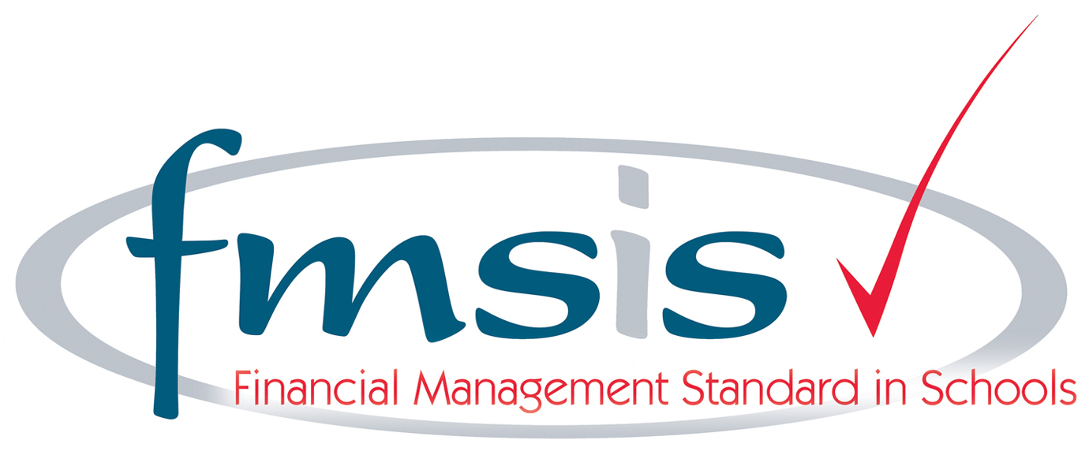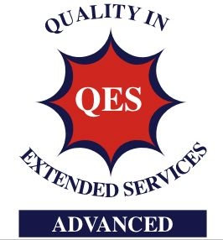 | Tel: 01304 812539  Fax: 01304 813853  E. Mail: office@ashckschool.org

January 2025

Dear parents/carers

Pupil Premium

You may be aware that the Government set up a Pupil Premium funding stream for disadvantaged pupils, which aims to raise attainment and close the gap between them and their peers. It is payable to pupils who:

• Are entitled to or are in receipt of free school meals

• Are children of service personnel, or have been in the past four years

• Are in care

• Have been adopted from care

• Have left care under a residential order or a specific guardianship order

The funding is directed specifically at the pupils in receipt of this funding and could be used
for items such as small group work, specific 1-2-1 sessions, learning mentoring, non-academic interventions, breakfast club, and help with costs for trips, equipment, uniform etc. It is discreet and pupils in receipt of it are not singled out in any way.

If you think your child may be eligible for pupil premium and you would like more information, please get in touch with us. We can let you know if you need to fill in any forms or bring in any documentation and can help with any paper work if necessary.

Yours faithfully

Mrs Fiona Crascall
Headteacher

