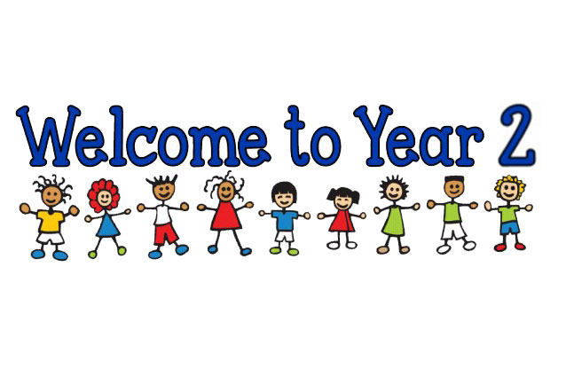

**Reading**

Reading books will be changed several times per week. Each morning I will ask your child if they need to change their reading books.

Every day the children will have opportunities to read both during morning registration and during our afternoon ‘DEAR time’ (drop everything and read time). Some children will be starting our ‘Accelerated Reading’ program where they will complete quizzes that test their comprehension of the books they have read. Others will continue using our colour coded books and shall read in guided groups.

I will try my hardest to make sure I hear your children read at least once a week.

Please do read with your child at home as often as possible, it makes such a difference and really boosts their love of books! Also I would encourage you to ask your children questions about the book they have read in order to boost their understanding of it. It is better that a child takes slightly longer to read a text and fully grasps its contents, than that child speeding through a text without having understood it.

**Spellings**

Spellings will be given out on a Friday and a spelling test will be completed the following Friday.

**Homework**

Now that the children are beginning to get back into the school routine, I will shortly be handing out their homework grids and homework books. These will consist of tasks and activities that are linked to the topics that we are learning this term.

Each topic will be worth house points and it is up to you and your child how many you complete over the forthcoming weeks. Tasks can either be handed in weekly or as a whole at the end of the term.

**Literacy/Topic**

This term we will be looking at

‘The Great Fire of London.’

This Great Fire of London unit will teach year 2 about the key events of the Great Fire of London, and help them develop an understanding of the ways in which we can find out about the past through discussing primary sources. In doing so, this unit also provides an introduction to Samuel Pepys and his famous diary. The children will have the opportunity to increase their awareness of the past by comparing and contrasting past and present-day London, as well as looking at how life was different in the 17th century.

**Maths**

In Maths this term we will be learning about place value, addition and subtraction, and measurements.

**Science**

Our focus for this term will be ‘Animals including Humans’. We’ll be looking at what animals need to survive, how animals change and grow, and what humans need to stay healthy.

**Medication**

If your child needs to take any medication please visit the office and fill in a medication form.

Please ask your child to bring in a bottle of water every day to make sure they stay hydrated!

**Welcome back Year 2 Parents!**

I hope you all had a brilliant summer!

My name is Miss Chatters and I’m the new Year 2 class teacher. I’m really looking forward to getting to know you all!

This year I am lucky enough to work alongside Mrs Brice in the mornings and Mrs Parker in the afternoons.

If you have any queries or concerns please feel free to come and talk to me after school.

Here’s some information for you about this term, I hope it is helpful!

**PE**

P.E. will be taught on Mondays and Tuesdays. Please ensure full PE kit is in school at all times.