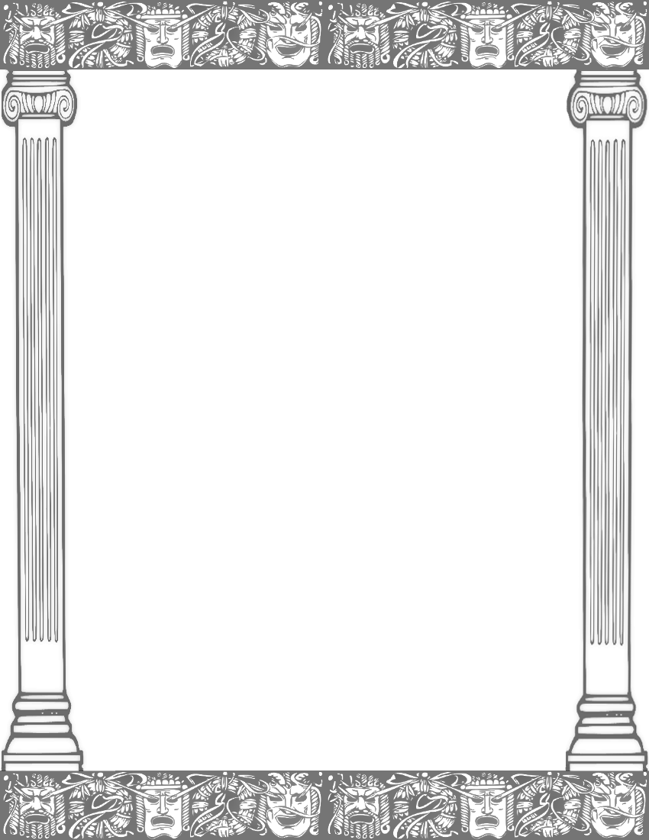
Dear Pupils, Parents and Guardians,
I hope you have all had a well-deserved rest over the last week and are ready for term 4. I was blown away last term by the hard work and dedication pupils showed during their class assembly and would like to take this moment to thank parents and guardians for all the help you provided.
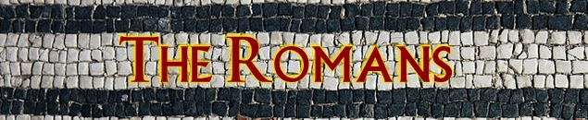
This term pupils will be transported back to Rome during our literacy and history lessons, learning about the daily life and culture of the Romans. Pupils will enter the world-famous colosseum and learn about life as a fierce gladiator.
During Mathematics the focus will turn to fractions and decimals and how to convert between them. Pupils will then learn how to relate this knowledge to a variety of reasoning and problem solving questions. As well as this, opportunities at home for reading with your child is highly recommended and spelling practice for our weekly tests.
Within Science, the children will be learning about states of matter and how these changes occur. The concept of the three states of matter will be covered, along with learning how materials can be changed from one state to another by heating and cooling.
PE will remain on a Monday and Thursday afternoon with myself and Mr Hayes, so full kits will be needed on these days. This term during my PE lessons, Hawks class will be focusing on invasion games, so children with earrings need to remove them prior to PE due to health and safety. The violin teacher will continue to come in every Thursday before lunch to teach the children for an hour.
A homework grid will be handed out alongside this letter containing a variety of activities to be completed. Each task will be worth house points and it is up to you and your child how many you complete over the forthcoming weeks. Tasks can either be handed in weekly or as a whole at the end of the term. If the piece chosen needs to be written up, please record this in the provided homework books.
If you have any queries or questions, please do not hesitate to contact me. I am at the door most days after school or if not please leave a message at the office or a note with your child to give to me.
Miss Spellman

