**Wembley**!

We will continue to learn the songs we shall be singning in March

In **English** this term we will be looking at a story set in the eruption of Vesuvius. We will be learning how to research information and write information texts, instructions and a balanced argument. 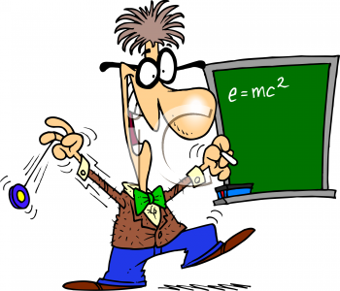

In **Maths** in we are going to be revisiting written skills and calculations then working on adding, subtracting, multipliying and dividing fractions and problem solving. Times tables knowledge is a **must** if children are to understand the Year 5 objectives quickly therefore we will be continuing the weekly times tables challenge. Please encourage your children to play on the Maths Prodigy and Times Tables Rockstar websites – those children playing regularly are making excellent progress in their quick recall of vital number facts. Their login details are in the front of their yellow reading record books.

Our **Science** this term is “Forces”. The class will be investigating how gravity, air and water resistance and friction affect objects. They will also learn how to represent balanced and unbalanced forces in diagrams.

As always – if you have any worries or concerns about your child please phone, visit or send in a note. Miss S Grahamhttp://www.pavendors.com/images/smileyface.gif



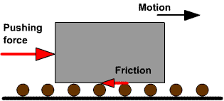

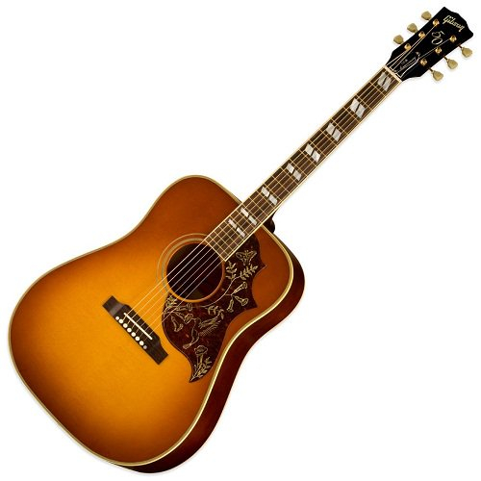

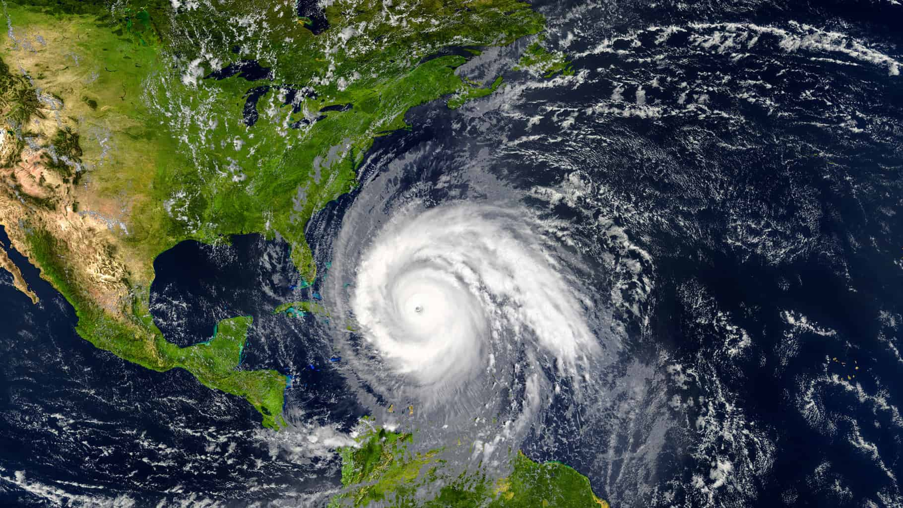

**Homework**: The learning grid will be going home this week with a variety of tasks to choose from. If your child is struggling with any of the homework then please let me know or write a note in their learning journal. We really do appreciate all the help you give your children with homework and reading!

**P.E.** Please ensure **all** PE kits are in school as of the first week.

**Mr. Hayes**

Mr. Hayes will be continuing his Mondays and Wednesday afternoons with Eagles class. The class will be having their PE, Music and French lessons with him

Welcome to Term 3!

This will be a very busy but slightly shorter term and there is a lot to cram in! We will have a fabulous “wow” day on Jan 7th where we will kick-start our topic on natural disasters and environmental change by designing and testing towers in an earthquake situation.

Our **topic** this term is “What makes the Earth angry?” We will be learning about the structure of the Earth, natural disasters relevant to today’s world and environmental change.

Spelling, punctuation and grammar (SPaG) lessons will be looking at the objectives of: different sentence types, determiners, adverbials, using different verb forms and a variety of punctuation.

**Eagles Class Newsletter**

**Term 3**