Our **Science** this term is “Forces”. The class will be investigating how gravity, air and water resistance and friction affect objects. They will also learn how to represent balanced and unbalanced forces in diagrams.

**Wembley**! We will begin

learning the songs we

shall be singing at

Wembley in March!

As always – if you have any worries or concerns about your child please phone, visit or send in a note.

Miss S Grahamhttp://www.pavendors.com/images/smileyface.gif



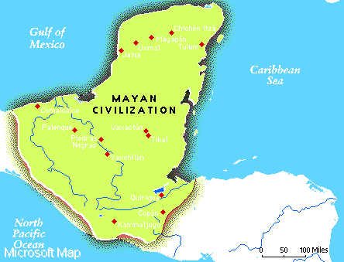

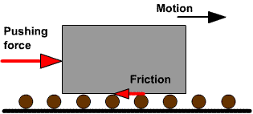



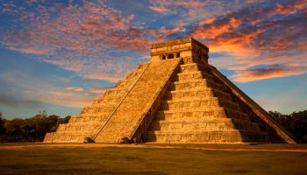

In **English** this term we will be looking at the Mayan stories “The Hero Twins” and “Rain Player”. We will be learning how to research information and write leaflets, narrative stories and instructions. I am looking forward in particular to having a food ‘experience’ with tortillas, guacamole, chilli and most excitingly – chocolate! 

In **Maths** in we are going to be revisiting written skills and calculations then working on adding, subtracting, multipliying and dividing fractions and problem solving. Times tables knowledge is a **must** if children are to understand the Year 5 objectives quickly therefore we will be continuing the weekly times tables challenge.

**Homework**: The learning grid is going home this week with a variety of tasks to choose from. If your child is struggling with any of the homework then please let me know or write a note in their learning journal. We really do appreciate all the help you give your children with homework and reading!

**P.E.** Please ensure **all** PE kits are in school as of the first week.

**Mr. Hayes**

Mr. Hayes will be continuing his Tuesday afternoon and Wednesdays with Eagles class. The class will be having their PE, Music and French lessons with him

Welcome to Term 3!

This will be a very busy but slightly shorter term and there is a lot to cram in! We will have a fabulous “wow” day creating clay models and starting Mayan death masks on the first day back in January – dress as Mayan or Central American animal!

Our **topic** this term is “The Maya Civilization”. We will be learning about where the Mayans came from, their daily lives, their Gods and worship, their buildings, food, art and stories.

Spelling, punctuation and grammar (SPaG) lessons will be looking at the objectives of: different sentence types, determiners, adverbials, using different verb forms and a variety of punctuation.

**Eagles Class Newsletter**

**Term 3**