In Literacy this term we will be looking at Sci-fi, journalistic writing and poetry . This is all in addition to ongoing grammar and spelling work. In Maths we are going to be revisiting multiplication and division, statistics, area and perimeter. Times tables knowledge is a **must** if children are to access the Year 5 curriculum and we will be continuing with the popular weekly times table challenge!

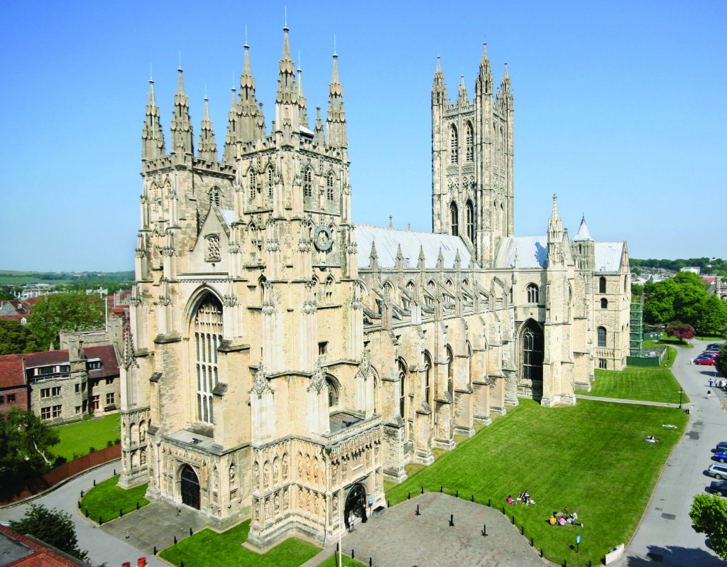

[](https://www.google.co.uk/url?sa=i&rct=j&q=&esrc=s&source=images&cd=&cad=rja&uact=8&ved=0ahUKEwi93NjE__3PAhUD6xQKHQoSDsgQjRwIBw&url=https://www.clipartsgram.com/happy-face-clipart-smiley-393&bvm=bv.136811127,bs.1,d.ZGg&psig=AFQjCNHtLzUmeDiKeZHDRGStQ4um5y96CA&ust=1477761176639830)

As always – if you have any worries or concerns about your child please phone, visit or send in a note.

Miss Graham

Canterbury Cathedral Trip Year 5 will be attending the bi-annual Y5/6 Cathedral Day for schools on Tuesday 6th November – don’t forget coats, packed lunches and an extra drink!

Homework grids will go home shortly and will have a variety of suggestions for home learning activities. In addition, your child should be bringing home a reading book every night. Times tables are ongoing as always - when you are in the car give your child a quick quiz or chant a table with them. If your child is struggling with any of the homework then please let us know or write a note in their reading journal. Weekly spelling lists will be sent home which are linked to the phonics they are studying in daily spelling work or high frequency words which are vital to all their writing.

We really do appreciate all the help you give your children with homework!

**P.E.** We will be doing some PE outside, so please ensure suitable PE for colder weather is included!

**Welcome to Term 2!**

The time is flying by and we are now settled into our Y5 routines quite happily.

Our topic this term is “Space” and all our cross curricular work will stem from this theme. We will have Guy Fawkes/Remembrance weeks to start the term off and then work on features of sci-fi, different types of poetry forms and journalistic writing.

RE this term is based on ‘Incarnation’ and will look at Jesus as the Messiah. Of course Christmas is on its way and will feature in our work towards the end of term. We will be making something Christmassy to sell at the Fair!

**Eagles Newsletter**

**Term 2**

[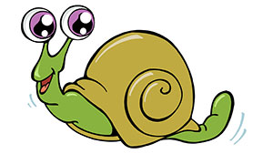](http://www.google.co.uk/url?sa=i&rct=j&q=&esrc=s&source=images&cd=&cad=rja&uact=8&ved=0ahUKEwiTrJW7gP7PAhXJuhQKHSU2DrcQjRwIBw&url=http://www.snail-world.com/&bvm=bv.136811127,bs.1,d.ZGg&psig=AFQjCNHqAFZldvCXVzVv2SsN1vhw3NJRCA&ust=1477761426954358)

Our Science this term is “Earth and Space”. Watch out for information about our Solar System, how we have day and night and the phases of the Moon!

We will be developing our scientific thinking and questioning skills, planning

investigations and drawing

conclusions.