Through God’s love and strength all flourish  * Achieve * Create * Know  Friday 17th November 2023 Newsletter Term 2 Week 3  Dear Parents/Carers  We have had a very successful maths week in school as the children have thought about 3 as the magic number. The children have taken part in various online sessions and challenges this week. We shared all our learning in the hall this morning as the children held a maths gallery. The children really enjoyed the opportunity to celebrate their learning – a big thanks to Mr Hayes for making sure the week ran smoothly. We are judging the maths house team competition this afternoon to collect house points for the winners.  The children cheered their way through the pantomime ‘Cinderella’ on Tuesday. A big thanks to M&M Productions for putting on such a great show. Alfie the cat even went in and watched – he got a special mention from the cast!  On Wednesday Mrs Wilson took the girls football team to Christchurch Academy in Dover for a Dover School Games football competition. The girls did not lose a single game and demonstrated all our school values – well done girls!  Next week we will be focusing on Anti-Bullying Week and the theme is Make a Noise About Bullying – we will end the week with Odd Socks Day on Friday.  Have a lovely weekend  Fiona Crascall  Headteacher  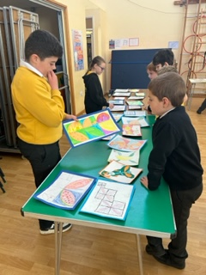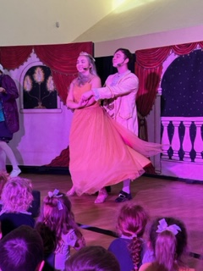 |  | 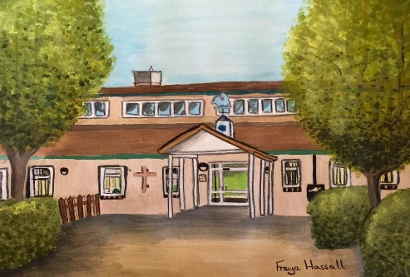  Birthdays to celebrate  Fledglings  Greyson  Robins  Eliza and Thomas  Hawks  Albie  School starters  If you have, or know somebody who has a child who will start school next year, please ring the school office to arrange an individual tour with me.
PTFA Update Friday 17th November

MYSTERY JARS
It’s that time of year again – please let us have your mystery jars!
For newbies to the school, these are used and cleaned jars – of any size – filled with all sorts of little bits and pieces, this can be anything from glow sticks, coins, sweets (wrapped only please), small toys, crafty bits, anything! These are then wrapped in wrapping paper so you cannot see what’s inside. The mystery jars are always very popular, so we need as many as possible.

If you can, please donate the jars already filled and wrapped; if not, any empty jar donations (washed please) can also be left at the school entrance in the box.

CHRISTMAS FAIR RAFFLE TICKETS
You will have received the letters and slips for raffle tickets by now. Once again, we have some excellent prizes in the offing, including a Le Shuttle voucher and the Sleigh of Merriment. Please let the school office know if you need any more tickets.

FATHER CHRISTMAS GROTTO AT THE CHRISTMAS FAIR
Letters have gone out now for you to request your times to see Father Christmas at the Christmas Fair! This is always a popular part of our Fair, so please get your dates in ASAP!

THANKS
Thanks to those who came to our recent Quiz Night at the school – and well done to the winning team!

TUCK SHOP
No Tuck Shop this week, we should be back next week with our usual array of items.

PRE-LOVED CHRISTMAS JUMPERS AND WINTER COATS
If you have any Nativity costumes, winter coats or Christmas jumpers that you’re no longer using, please consider donating them to the PTFA! Between now and the end of term we will be selling these (for very reasonable prices) at Tuck Shop. Please bring your donations to us at Tuck shop, give to a PTFA committee member or hand in at the school office.

UPCOMING DATES
The PTFA have a pinned post on the school’s Facebook page with dates of our upcoming events. We update this regularly, so you have easy access to the latest information almost as soon as we do.

ABOUT THE PTFA
The PTFA is an integral part of the school community and is made up of parents, carers, teachers and friends of the school. All parents and carers are automatically members. We are charity reg. number 1042205.
Read more on the school website https://www.ashckschool.org/about-us/ptfa

All the money we raise goes back into the school to benefit the children and enrich their education.

Fledglings
Year 1 Robins
Year 2 Magpies
Year 3 Owls
Year 4 Hawks
Year 5 Eagles
Year 6 Falcons
Week Ending  17/11/2023 |  | %

Dates for your diary
Week 20th November | Anti-bullying week in school – theme is Make a Noise about Bullying
Friday 24th November | Odd socks day in school to end anti-bullying week
Tuesday 21st November | Parent teacher meetings 3.20 – 5.30pm
Wednesday 22nd November | Parent teacher meetings 3.20 – 5.30pm
Thursday 23rd November | Year 5 to Ash Heritage as part of their Victorian topic
Friday 1st December | Christmas Fair after school in the school hall
Thursday 7th December | i-rock concert in school 9.30am
Friday 8th December | Christmas Cracker Day in school – children to make crowns crackers and placemats ready for Christmas Dinner
Tuesday 12th December | Christmas jumper day and school Christmas dinner
Wednesday 13th December | KS1 nativity to parents – 1.45 in the school hall
Thursday 14th December | Christmas Service at the Church – 1.45 then back to school and end of term 2. Parents of year 6 welcome
Friday 15th December | INSET day – no children in school
Tuesday 2nd January | INSET day – no children in school
Wednesday 3rd January | WOW day and children back in school

