**Spellings**

Robins have been doing really well in their spellings. Spellings will be handed out every Friday and the test will be the following Friday. Please try and practice the weekly spellings with your children.

**Reading Books**

Reading books will be changed daily if needed. Every morning I will check your child’s home reading log. Please make sure you keep these updated as I will not change their books unless an adult has written that they finished them at home.

Your child will read every day during our DEAR (drop everything and read) time. This is when the children have time to read their reading books independently.

I will try my hardest to make sure I hear your children read at least once a week.

Please try and read at home with your child when possible.

**PE**

Wednesday Afternoon- Teamwork

Friday Afternoon- Bat and Trap

Please ensure full PE kit is in school at all times.

**Welcome Back Robins Class!**

I hope you all had a lovely break, it is hard to believe that we are already half way through the school year.

The children had a very busy term but they all worked fantastically hard. We had a wonderful school trip to Dover museum where we learnt all about castles and made clay shields. It was a brilliant day.

Here is some information about this term.

**Homework**

I was amazed with the homework that I received last term. Every term I am wonderfully surprised with the amount of effort that goes into these tasks. Some students made brilliant castle models last term which will be on display outside the classroom. Please come and have a look.

I will be handing out this terms homework grid on Friday 1st March. This grid will consist of tasks and activities that are linked to the topics that we are learning this term.

Each topic will be worth house points and it is up to you and your child how many you complete over the forthcoming weeks. Tasks can either be handed in weekly or as a whole at the end of the term.

**Have fun Robins**!

**Reports**

Reports will be handed out Thursday 28th February. Please feel free to come and see me if you wish to discuss your child’s report.

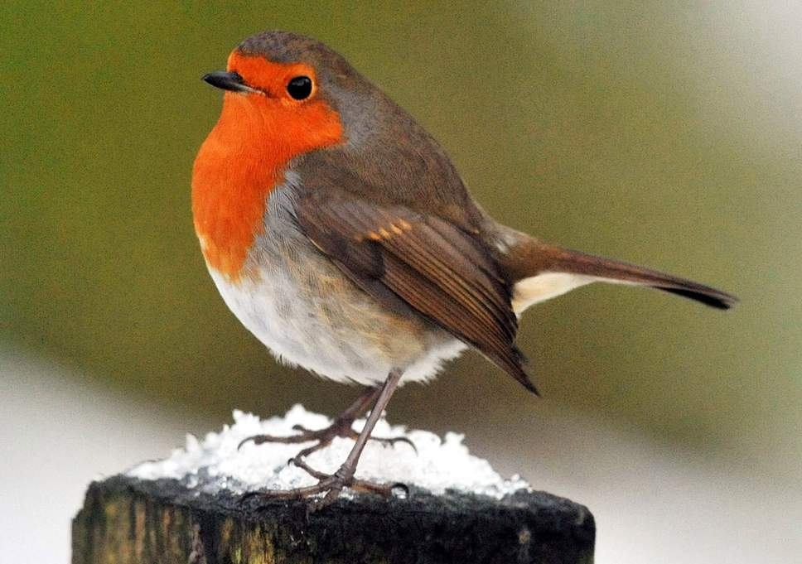

**All the best**

**Miss Harney**

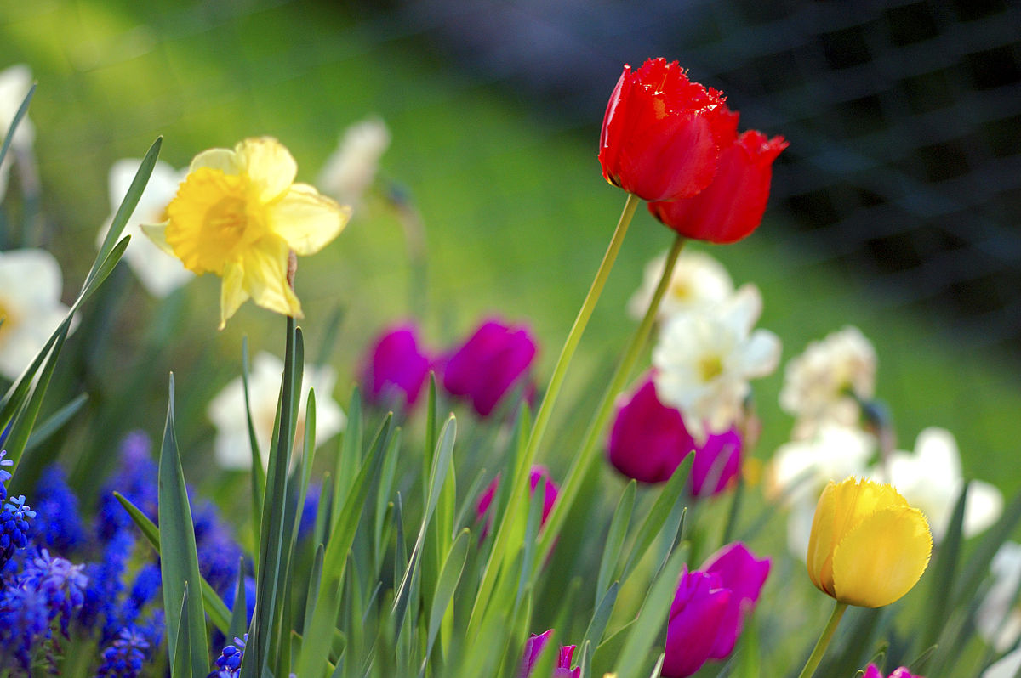

**Topic!**

Our topic this term is

Katie Morag and the Isle of Struay.

Robins will be packing their bags and travelling to Scotland to learn about all the different adventures of Katie Morag.

I am sure the children will enjoy these wonderful stories.

**Maths!**

This term we will be learning about different types of measurements including height, weight and volume.

**Science!**

Our Big Idea in Science this term is ‘The natural world outside changes at different times of the year’. We will be looking at different seasons especially spring.