PSHE Policy

Ash Cartwright and Kelsey CE Primary School

Our Christian vision guides our journey to provide a rich, well-rounded education enabling all to become the very best that
God intended. We treat adults and pupils with love and dignity in a space where Christian values are developed
and everyone can flourish.

Friendship Joy Community Forgiveness Perseverance Creation

This set of values is reflected in all our policies.

Date agreed: May 2021
Review date: May 2022

We believe that PSHE and citizenship should enable children to become healthier, more independent and more responsible members of society. We encourage our children to play a positive role in contributing to the life of the school and the wider community. In so doing, we help develop their sense of self-worth. We teach them how society is organised and governed. We ensure that the children experience the process of democracy through participation as School Council members, Eco-Councilors and Worship Councilors. We teach children both about their rights and about their responsibilities. They learn to appreciate what it means to be a positive member of a diverse and multicultural society.

At Ash, Cartwright and Kelsey CE school our personal, social and health education (PSHE) programme runs alongside our Relationships and Sex Education (RSE) Policy. It promotes children's personal, social and economic development, as well as their health and wellbeing. It helps to give children the knowledge, skills and understanding they need to lead confident, healthy, independent lives and to become informed, active, responsible citizens. Children are encouraged to take part in a wide range of activities and experiences across and beyond the curriculum, contributing fully to the life of our school and community.

They learn to recognise their own worth, work well with others and become increasingly responsible for their own learning. They reflect on their experiences and understand how they are developing personally and socially, tackling many of the spiritual, moral, social and cultural issues that are part of growing up. It gives children an understanding of the rights and responsibilities that are part of being a good citizen and introduces them to some of the principles of prudent financial planning and understanding. They learn to understand and respect our common humanity, diversity and differences so that they can go on to form the effective, fulfilling relationships that are an essential part of life-long learning.

As a Church of England school, our PSHE and RSE school policies also adhere to the Church of England ‘Valuing All God’s Children’ document (September 2019). This states that:

One of the four strands of the Church of England Vision for Education is dignity and respect. Part of this vision is to create a culture where children can grow to be content, living well in their own skin, and happy for others for the skin they’re in. This happens best in a culture of love that accepts, forgives and keeps faith with children and young people as they explore questions of identity and selfhood.

Reference to RSE Policy:

In creating a school environment that promotes dignity for all and a call to live fulfilled lives as uniquely gifted individuals, pupils will be equipped to accept difference of all varieties and be supported to accept their own gender identity or sexual orientation and that of others. In order to do this, it will be essential to provide curriculum opportunities where difference is explored, same-sex relationships, same-sex parenting and transgender issues may be mentioned as a fact in some people’s lives. For children of same- sex or transgender parents or with close LGBT relatives this will be a signal of recognition that will encourage self-esteem and belonging.

In the early years’ context and throughout primary school, play should be a hallmark of creative exploration. Pupils need to be able to play with the many cloaks of identity (sometimes quite literally with the dressing up box). Children should be at liberty to explore the possibilities of who they might be without judgement or derision. For example, a child may choose the tutu, princess’s tiara and heels and/or the firefighter’s helmet, tool belt and superhero cloak without expectation or comment. Childhood has a sacred space for creative self-imagining.

At Ash Cartwright and Kelsey school, we regard PSHE as an important, integral component of the whole curriculum and we strongly promote our values through our day to day dealings with children and adults. We provide a broad and balanced curriculum, ensuring that it:

- Promotes the spiritual, moral, cultural, mental and physical development of our children and of society.
- Prepares our children for the opportunities, responsibilities and experiences they already face and for adult life.
- Provides information about keeping healthy and safe, mentally, emotionally and physically.
- Encourages our children to understand how all actions have consequences and how they can make informed choices to help themselves, others and the environment.

Aims

The aims of PSHE and Citizenship fall into 3 core themes: Health & Wellbeing, Relationships and Living in the Wider World.

Health & Wellbeing
- Know and understand what constitutes a healthy lifestyle.
- Know how to maintain physical, mental and emotional health and wellbeing.
- Be aware of safety issues, including how to respond in an emergency.
- Know how to manage change, including puberty, transition and loss.
- Know how to promote and maintain good mental health.

Relationships
- Develop and maintain a variety of healthy relationships within a range of social and cultural contexts.
- Know how to recognise and manage emotions within a range of relationships.
- Know how to recognise risky or negative relationships, including all forms of bullying and abuse, and ask for help.
- Know how to respect equality and diversity in relationships.

Living in the Wider World
- Know the importance of responsible behaviours and actions.
- Be responsible and independent members of the school community.
- Be positive and active members of a democratic society.
- Know about the importance of respecting and protecting the environment.
- Develop self-confidence and self-esteem and make informed choices regarding personal and social issues.

- Develop good relationships with other members of the school and the wider and global community.
- Know about where money comes from, keeping it safe and the importance of managing it effectively.
- Have a basic understanding of enterprise.

PSHE and citizenship curriculum planning

At Ash Cartwright and Kelsey, we use the PSHE Association approach. This is taught through a spiral curriculum which allows for children to regularly re-visit areas of the PSHE curriculum. Where possible, teaching is interwoven into our whole school enquiry- based approach, ensuring that learning is both relevant and purposeful. Through a spiral curriculum approach, this enables us to build on prior knowledge and skills, deepen understanding and equip children with the age-appropriate skills. We teach PSHE in a variety of ways. Sometimes, for example, when dealing with issues in drugs education, we teach PSHE as a discrete subject.

On other occasions, we introduce PSHE topics through teaching in other subjects. Also, as there is a large overlap between the programme of study for Religious Education and the aims of PSHE. We deliver a considerable amount of the PSHE curriculum through our Religious Education lessons. We also develop PSHE through various activities and whole-school events, for example the school council representatives from each class meet regularly to discuss school matters. We offer residential visits in Key Stage 2, where there is a particular focus on developing pupils’ self-esteem, and giving them opportunities to develop leadership skills and positive group work.

The Early Years Foundation Stage

We teach PSHE and citizenship in Reception as an integral part of the curriculum. As the
reception class is part of the EYFS, we relate the PSHE aspects of the children’s work to the objectives set out in the Early Learning Goals (ELGs). Our teaching in PSHE matches the aim of developing a child’s personal, emotional and social development as set out in the ELGs. We also support citizenship education in Reception classes, when we teach ‘Understanding the World’.

SEND

We teach PSHE and citizenship to all children, regardless of their ability. Our teachers provide learning opportunities matched to the individual needs of children with learning difficulties. We believe that PSHE must be accessible for all our pupils. This is particularly important when planning teaching for pupils with special educational needs and disabilities who represent a large minority of pupils.

We provide quality teaching that is differentiated and personalised which will be the starting point to ensure accessibility. We are also mindful of preparing children for adulthood outcomes, as set out in the SEND code of practice, when teaching these subjects to those with SEND.

At Ash Cartwright and Kelsey, we are aware that some pupils are more vulnerable to exploitation, bullying and other issues due to the nature of their SEND. Relationships Education and RSE can also be particularly important subjects for some pupils; for example, those with Social, Emotional and Mental Health needs or learning disabilities. These factors should be taken into consideration when teaching these subjects.

PSHE and computing

Computing contributes to the teaching of PSHE in that children in computing classes learn to work together in a collaborative manner. They also develop a sense of global citizenship by using the internet and email. With continuing advances in the use of technology in our society, we ensure that our children are fully equipped with the latest advice on how to stay safe online. This is taught explicitly through our PSHE along with addressing specific safeguarding issues as they arise. This advice and teaching continually evolves to take account of current changes and updates. (See E-Safety Policy)

Strategies

At Ash Cartwright and Kelsey, a wide range of teaching and learning styles are evident in lessons and an emphasis is placed upon active learning. We emphasise active learning by including the children in discussions, investigations and problem-solving activities. Children are encouraged to take part in a range of practical activities that promote active citizenship, e.g. charity fundraising, the planning of school special events such as a Collective Worship, or involvement in an activity to help other individuals or groups less fortunate than themselves. Classes are organised in such a way that children are able to participate in an open friendly forum where agreed classroom expectations of behaviour have been agreed.

Relationships within School

Relationships at Ash Cartwright and Kelsey are based on an atmosphere of trust and respect for everyone. Our School behavior policy is underpinned by Christian teachings based upon our school vision.

“Our Christian vision guides our journey to provide a rich, well-rounded education enabling all to become the very best that God intended. We treat adults and pupils with love and dignity in a space where Christian values are developed and everyone can flourish.”

Children are supported through the Restorative Justice approach to develop good relationships with their peers and all staff and to take responsibility for their own behaviour. All staff are very good role models for children and work hard to promote a safe, happy environment. The children have an active School Council, where two children from each class are elected to represent the class’ views in each of these areas.

Equal Opportunities

All children have the opportunity to take part in our PSHE programme. As PSHE has been planned to cover all areas recommended by the National Curriculum, then issues can be met and discussed which may otherwise not arise informally. It is intended that PSHE supports the personal and social development of children at home.

Assessment, Recording and Reporting

Children are informally assessed by staff throughout their work and the reports given to parents will reflect this. Recording of work will be in a form appropriate to the planned focus and will be shown in teacher’s planning. Evidence of PSHE will be in a variety of forms e.g. photographs as well as written work and through the class big books. The very nature of PSHE means that careful consideration should be given to the best means of recording. Written work may not always be appropriate and staff will use their professional judgment in this.

Monitoring, evaluation and review

The PSHE Lead and Head Teacher are responsible for monitoring the standards of children’s work and the quality of teaching and learning. The PSHE Lead supports colleagues in their teaching by giving them information about current developments in the subject, and by providing a strategic lead and direction for the subject in the school. The PSHE Lead is also responsible for giving the Head Teacher an informal annual summary report, evaluating strengths and weaknesses in the subject, and indicating areas for further improvement.

The school will review this policy annually and assess its implementation and effectiveness regularly.

Prevent Duty

Since July 2015, schools and a range of other public bodies have a legal responsibility to give due regard to the need to prevent children and young people from being drawn into terrorism. This is known as the Prevent duty and is part of the schools wider safeguarding.

Ash Cartwright and Kelsey has a clear policy in place for protecting children at risk of radicalisation. This can be found on the school website and is part of the schools overarching safeguarding policy.

Statutory Requirements

PSHE is statutory as of Term 5 2021. In line with DfE statutory requirements, from 2021 all areas of Health Education and Relationships Education are now statutory. Areas of the curriculum which relate to Science teaching are also statutory. As a school, and in consultation with parents we have made the decision to not provide additional Sex Education beyond the National Curriculum Science content covering puberty and reproduction. Parents do not have a right to withdraw their children from this as it is part of the Science curriculum and NOT Sex Education – see Right to Withdraw (RSE policy).

Parents do not have the right to withdraw their children from relationships and health education which forms part of the PSHE curriculum.

Safeguarding

Teachers’ conduct RSE lessons in a sensitive manner, and in confidence. However, if a child makes a reference to being involved (or being likely to be involved) in sexual activity, then the teacher will take the reference seriously, and deal with it as a matter of child protection. Teachers will respond in a similar way if a child indicates that they may have been a victim of abuse. They will not try to investigate, but will immediately inform the named person for Child Protection issues (Assistant Heads, Deputy and/or Head teacher) about their concerns. They will then deal with the matter in consultation with health care professionals (see also our policy on Child Protection and Safeguarding). School staff cannot promise absolute confidentiality if approached by a child for help. Staff must make this clear to children. Child protection procedures must be followed when any disclosures about abuse are made.

In line with the statutory arrangements for Health Education and Relationships Education, here are the expectations for the end of Key Stage 2. This is an end point for what the children should know by the end of the primary phase. We use these to help build a progression of knowledge, skills and understanding throughout each Key Stage.

Timeline of actions

Consultation with parents | Autumn 2020
Share draft RSE Policy with Governors | Oct 2020
Policy agreed by Governors | Dec 2020
Draft PSHE policy shared with staff | March 2021
PSHE Policy agreed by Governors | May 2021

Links to other documents:
- Safeguarding Policy
- Health and Safety Policy
- PE Policy
- PSHE Policy
- ICT Policy
- SEND Policy
- Prevent (Radicalisation and Extremism) Policy
- First Aid Policy
- E-Safety Policy
- RE Policy

- Equality and Diversity Policy
- Early Years Policy
- Church of England – Valuing All God’s Children (Sept 2019)

Relationship Education (Statutory from 2021)

TOPIC | PUPILS SHOULD KNOW
Families and people who care about me | - That families are important for children growing up because they can give love, security and stability  - The characteristics of healthy family life, commitment to each other, including in times of difficulty, protection and care for children and other family members, the importance of spending time together and sharing each other’s lives  - That others’ families, either in school or in the wider world, sometimes look different from their family, but that they should respect those differences and know that other children’s families are also characterised by love and care  - That stable, caring relationships, which may be of different types, are at the heart of happy families, and are important for children’s security as they grow up  - That marriage represents a formal and legally recognised commitment of two people to each other which is intended to be lifelong  - How to recognise if family relationships are making them feel unhappy or unsafe, and how to seek help or advice from others if needed
Caring friendships | - How important friendships are in making us feel happy and secure, and how people choose and make friends  - The characteristics of friendships, including mutual respect, truthfulness, trustworthiness, loyalty, kindness, generosity, trust, sharing interests and experiences and support with problems and difficulties  - That healthy friendships are positive and welcoming towards others, and do not make others feel lonely or excluded  - That most friendships have ups and downs, and that these can often be worked through so that the friendship is repaired or even strengthened, and that resorting to violence is never right  - How to recognise who to trust and who not to trust, how to judge when a friendship is making them feel unhappy or uncomfortable, managing conflict, how to manage these situations and how to seek help or advice from others, if needed

TOPIC | PUPILS SHOULD KNOW
Respectful relationships | - The importance of respecting others, even when they are very different from them (for example, physically, in character, personality or backgrounds), or make different choices or have different preferences or beliefs  - Practical steps they can take in a range of different contexts to improve or support respectful relationships  - The conventions of courtesy and manners  - The importance of self-respect and how this links to their own happiness  - That in school and in wider society they can expect to be treated with respect by others, and that in turn they should show due respect to others, including those in positions of authority  - About different types of bullying (including cyberbullying), the impact of bullying, responsibilities of bystanders (primarily reporting bullying to an adult) and how to get help  - What a stereotype is, and how stereotypes can be unfair, negative or destructive  - The importance of permission-seeking and giving in relationships with friends, peers and adults
Online relationships | - That people sometimes behave differently online, including by pretending to be someone they are not  - That the same principles apply to online relationships as to face-to face relationships, including the importance of respect for others online including when we are anonymous  - The rules and principles for keeping safe online, how to recognise risks, harmful content and contact, and how to report them  - How to critically consider their online friendships and sources of information including awareness of the risks associated with people they have never met  - How information and data is shared and used online
Being safe | - What sorts of boundaries are appropriate in friendships with peers and others (including in a digital context)  - About the concept of privacy and the implications of it for both children and adults; including that it is not always right to keep secrets if they relate to being safe  - That each person’s body belongs to them, and the differences between appropriate and inappropriate or unsafe physical, and other, contact  - How to respond safely and appropriately to adults they may encounter (in all contexts, including online) whom they do not know  - How to recognise and report feelings of being unsafe or feeling bad about any adult  - How to ask for advice or help for themselves or others, and to keep trying until they are heard  - How to report concerns or abuse, and the vocabulary and confidence needed to do so  - Where to get advice e.g. family, school and/or other sources

Physical health and mental well-being education (Statutory) in Primary schools – what should be included.

The focus in primary school should be on teaching the characteristics of good physical health and mental wellbeing. Teachers should be clear that mental well-being is a normal part of daily life, in the same way as physical health.

By the end of primary school:

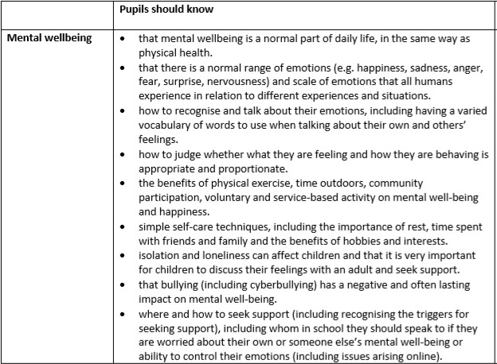

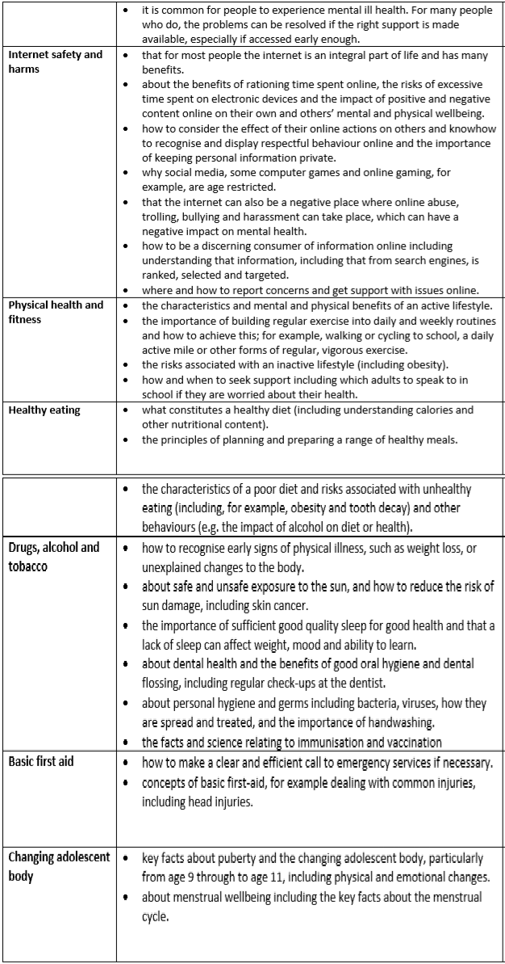

St Paul’s Church of England Primary School

PSHE Policy

