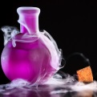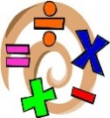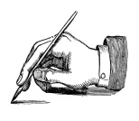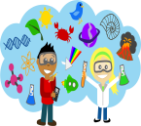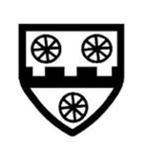

Term 2

Thank you for your continued support, I’ll look forward to meeting all the parents and guardians more formally at our parents evenings this term.

If there are any questions, issues or queries on how to help your child at home, please don’t hesitate to see me at the classroom door at the end of school or book an appointment via the office.

**What Lurks Beneath The Sea?**

Our topic this term is all about the seas and oceans, creatures and shipwrecks, and more!

We will also be learning about pollution and climate change, how these things are having an impact on our seas, and what we can do to have a positive impact.

**PE**   
PE sessions will take place on Wednesdays and Thursdays.

PE lessons will be taking place outside as well as in the hall so please ensure children have the appropriate footwear to complete the lessons outside. Trainers are needed when we are on the field and plimpsolls or trainers are suitable for the playground.

Children will also need to bring a water bottle to school as we will take this outside on the days of our PE lessons.

**Welcome back to school! I hope you had a lovely half term break! I am very excited for our topic this term.**

**English and Maths**

Our English lessons will be linked to our topic this term. We will be reading an amazing book called Flotsam, as well as some non-fiction books about the seas and oceans. We will be writing newspaper reports, persuasive letters and non-chronological reports.

In maths, we will be continuing our learning about addition and subtraction, and moving onto multiplication and division. We will learn new written methods, and continue to apply what we are learning to problem solve.

**Home Learning/ Trips**

Thank you all for some incredible homework shared last term!

If the children would like to show their homework to the class, please bring it in on a Monday . Otherwise, I will mark homework at any time and return within two days.

**Other Subjects**

Science: Animals and Humans

Art: Water-colour Painting

PE: Dance and Handball

RE: Other Faiths- Sikhism

Geography – Oceans and Seas

### ACK CEP School

TERM 2 2019

CLASS NEWSLETTER

What’s going on in

Owls Class this term?

banner with apples and crayons