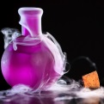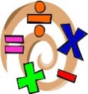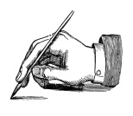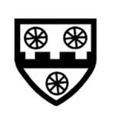

Thank you for your continued support

**PE**   
PE sessions will still take place on a   
Tuesday and Thursdays. Tuesday sessions will be taken by Mr Hayes.

Mr Hayes will be teaching them dance this term and Miss Horton will teach them handball. These sessions will be mostly take place in the hall but children need to have warm clothes and suitable footwear in case they go outside.

**Welcome back! We hope you had a fantastic half term and are excited for the term 2 and the run up to Christmas.**

**Under The Sea**

Our topic this term is under the sea. It will be mostly geography based focusing on locating different oceans and seas, what the oceans are used for, pollution and what animals we can find in the oceans.

**English and Maths**

Our English lessons will be linked to our topic this term. We will be reading the book Manfish which is a biography of a famous Diver Jacques Cousteau. We will write a diary entry as Jacques, imagining what is like exploring underwater. We will also write a nonfiction piece which will be to persuade people to look after the oceans and seas and stop polluting.

In maths, we will continue to look at written methods for addition and subtraction and how to solve problems using these operations. We will then move on to mental multiplication and division and a written method for both.

**Home Learning/ Trips:** Thank you for all effort put into the homework last term. Thank you for supporting your children with their learning. There will be another grid given out this term which links to the new topic.

On the grid there will be a math piece which will link with what we have covered so far this year.

We encourage children to practice number facts and read with an adult as well as completing the grid.

**Other Subjects**

Science: Plants

Art: Mosaic

PE: Dance and Handball

RE: Sikhism

Geography: Under the sea

If there are any questions, issues or queries on how to help your child at home, please don’t hesitate to see me at the classroom door at the end of school or book an appointment via the office.

### ACK CEP School

TERM 2 2018

CLASS NEWSLETTER

What’s going on in

Owls Class this term?

Back to   
School!

banner with apples and crayons