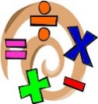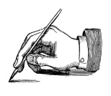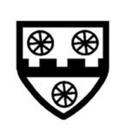

Thank you for your continued support, I’m really looking forward to getting to know everybody!

**Ancient Greece**

Our topic this term is Ancient Greece. It will be mostly history based focusing on who the Greeks were and what influence they had on life today. There will be some aspects of geography as we locate Greece and discuss their climate and famous cities.

**PE**   
PE sessions will take place on Wednesdays and Thursdays.

PE lessons will be taking place outside as well as in the hall so please ensure children have the appropriate footwear to complete the lessons outside. Trainers are needed when we are on the field and plimsolls or trainers are suitable for the playground.

Children will also need to bring a water bottle to school as we will take this outside on the days of our PE lessons.

**Welcome back to school! We are all very pleased to see everyone refreshed from a lovely summer holiday, and so eager to learn! We are very excited to get stuck in with lots of fun learning! From Miss Marlow, Mrs Brice and Mrs Parker.**

**English and Maths**

Our English lessons will be linked to our topic this term. We will be reading Greek myths and creating our own myth using the specific features. For our nonfiction piece of writing, we will write a newspaper report based on the events that occur in one of the Greek myths

In maths, we will be looking in depth at place value of 3-digit numbers and moving on to adding mentally and using written methods. Throughout both maths units, there will be a strong focus on reasoning and problem solving.

**Home Learning/ Trips:** This year the homework will be similar to previous years. The children will have a grid with a range of different activities linked to the current topic. Each activity is worth a number of house points which will count towards their house’s end of term score.

We would also welcome as much support in reading with your child at home, learning weekly spellings and practising mental maths skills.

**Other Subjects**

Science: Magnets and forces

Art: Greek vases

PE: Basketball and Gymnastics

RE: Christianity – People of God

History: Ancient Greece

If there are any questions, issues or queries on how to help your child at home, please don’t hesitate to see me at the classroom door at the end of school or book an appointment via the office.

### ACK CEP School

TERM 1 2019

CLASS NEWSLETTER

What’s going on in

Owls Class this term?

Back to   
School!

banner with apples and crayons