Through God’s love and strength all flourish  * Achieve * Create * Know  Friday 23rd February 2024 Newsletter Term 4 Week 1  Dear Parents/Carers  Welcome back to term 4 – I hope you all had a lovely half term break. – Lenny the dog was very happy to be back. The children have come back keen and eager to learn about their new topics. As part of their ‘How can we protect the creatures that live in and around Ash?’ topic, Magpies were looking at microhabitats in their science lesson – we are lucky to have such fantastic grounds for the children to explore.  Year 5 went to the observatory at the University of Kent today and will spend this afternoon at the Beaney museum in Canterbury looking at Anglo-Saxon artefacts as part of their Anglo-Saxon topic. They have travelled in the school minibus and I must say a huge thanks to the PTFA for purchasing new tyres for the minibus as part of feedback from the MOT. We do use the minibus for lots of trips and visits and it really enhances the education of our children.  We have lots of exciting trips and Easter events planned so please keep a look out for details of upcoming events.  Have a lovely weekend  Fiona Crascall  Headteacher  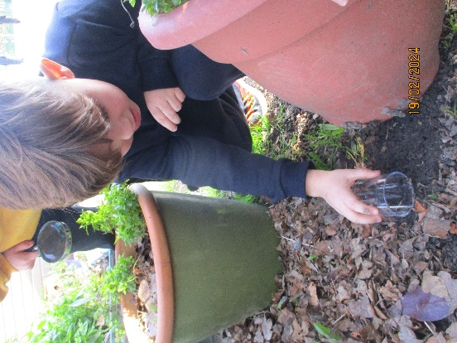 |  | 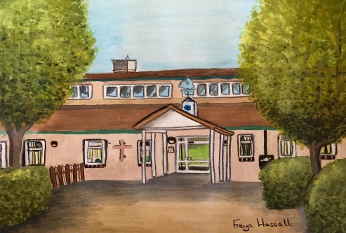  Birthdays to celebrate  Robins  Tilly and Dotty  Magpies  Nancy  Falcons  Lina  School starters  If you have, or know somebody who has a child who will start school next year, please ring the school office to arrange an individual tour with me.
PTFA Update

CHOCCY WOCCY RAFFLE!!!
Next Thursday (29th February) is the day of our Choccy Woccy Raffle! You should have all received your pre-order forms on Tuesday and handed them in by today – if you’ve yet to do this then please make sure that they are handed in by Monday morning so we have time to get all the orders together. We will have some bars available to buy on the day, but this will be a limited amount and we don’t want anyone to miss out! On Thursday, we will be in the playground after school for you to collect your orders; if anyone is unable to pick up their order that day (if your child is absent etc), we will leave them at the school office for collection. If you are lucky enough to find one of our shiny winning tickets in your Choccy Woccy bar, then either let us know there and then – we know some of you won’t be able to resist ripping the wrapper off straight away! – or take your winning ticket to Mrs Bailey in the school office from the next day to get your name put on the winners list! We’ll then be in touch with all the winners about the details of their prize the following week

TUCK SHOP
No Tuck shop today. Also, our Choccy Woccy Raffle will be taking place next week (on Thursday) instead of Tuck.

EASTER DISCO – DATE CHANGE!
Our Easter Disco will now be taking place on Wednesday 27th March – letters with further details will be coming home soon, so keep an eye out! Thanks to the school for accommodating this change for us, it’s much appreciated!

PLEASE NOMINATE YOUR PTFA!
*** Huge thanks to those that have already done this, but the more the merrier! ***
The Benefact Group is an organisation that regularly gives to charities and good causes through its ‘Movement for Good’ scheme – all that’s needed is a nomination. It takes only a couple of minutes to nominate your chosen charity and we could receive a massive £1,000! Just head to https://benefactgroup.com/movement-for-good/ and click ‘Nominate a Charity for £1,000’. On the next page enter the charity number 1042205 to find us. Every entry helps so we really appreciate you taking the time to do it; thank you!

About the PTFA
The PTFA is an integral part of the school community made up of parents, teachers and friends of the school. All parents & carers are automatically members. We are charity reg. number 1042205. Read more on the school website https://www.ashckschool.org/about-us/ptfa

All money raised goes back into the school to benefit the children.

Week Ending  23/02/2024 |  | %

Fledglings
Year 1 Robins
Year 2 Magpies
Year 3 Owls
Year 4 Hawks
Year 5 Eagles
Year 6 Falcons

Dates for your diary
Thursday 7th March | World Book Day – children to wear pyjamas and bring in favourite book and teddy bear
Monday 11th March | Captain Wonderweb NHS workshops in school
Monday 18th March | Diversity Week – each class will focus on a different Continent - more details to follow
Tuesday 26th March | EYFS Easter activities at the Church
Wednesday 27th March | PTFA Easter Disco after school
Thursday 28th March | Easter Service at the Church 1.45pm – year 6 parents very welcome to attend – end of term 4
Monday 15th April | Children back in school for term 5
Tuesday 23rd April | PTFA film afternoon
Monday 6th May | Bank Holiday – no children in school
Monday 13th May | Year 6 SATs week
Monday 20th May | Science week in school
Friday 24th May | End of term 5

