Ash Cartwright and Kelsey CEP School
Through God’s love and strength all flourish
* Achieve * Create * Know
Friday 20th March 2020 Newsletter No: 23
Dear Parents/Carers
We had a great start to science week and Miss Chatters led a whole school assembly introducing our theme ‘What’s in the sky?’ The children enjoyed the astrodome on Tuesday and enjoyed learning about the stars and the planets - pupils told me it was ‘amazing’. We also had an assembly and workshops on Wednesday from the ‘Ministry of Chocolate’. The children learnt all about the process of chocolate making – from cacao trees in countries near the equator to the shops/supermarkets. Years 3 and 4 got to make their own chocolate bars and the looked delicious!

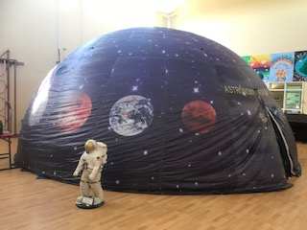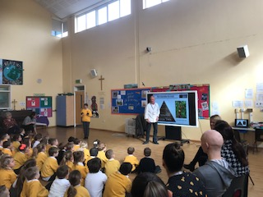

On Thursday the children learnt all about the birds that their classes are named after. Year 5 made some bird food and were very unimpressed by the smell of lard! Year 3 learnt all about Owls and John told me ‘They see their prey in the dark and they don’t make a flappy noise with their wings. Their ears are in different places and under their feathers’.

I have to say, I have been extremely proud of our staff team this week – they have been amazing. They have dealt calmly with the pupils during, what could be, a time of anxiety. A big thank you to all you parents/carers as well for being supportive – the support of our community is very much appreciated.
Take care and see you all soon
Fiona Crascall
Headteacher

Active Health Conference
We have had notification that they are postponing all Active Health conferences and they will be touch ASAP with new conference dates.

PTFA Easter Egg Hunt
We ended the week on a high – our wonderful PTFA supplied chocolate eggs for a surprise Easter Egg Hunt – the children really appreciated this. It was lovely to see them all running around the field and enjoying the experience. Thank you PTFA!

Coronavirus
Government coronavirus action plan
The government coronavirus action plan sets out what the UK has done to tackle coronavirus (COVID-19), and what we plan to do next.
The situation is constantly reviewed and action informed by expert science and advice, guided by the Chief Medical Officer and the Chief Scientific Adviser.
The action plan can be found here:
https://www.gov.uk/government/publications/coronavirus-action-plan
Staff, parents and young people can contact the helpline as follows:

Phone: 0800 046 8687
Email: DfE.coronavirushelpline@education.gov.uk
Opening hours: 8am to 6pm (Monday to Friday)

Thank you for your support.

