Ash Cartwright and Kelsey CEP School
Through God’s love and strength all flourish
* Achieve * Create * Know
Friday 12th July 2019 Newsletter No: 37

Dear Parents/Carers
As usual it has been a very busy week in our school. EYFS have produced some fantastic writing about Jack and the Beanstalk and Year 1 have been busy learning about time, Aliona said ‘when both of the arrows are pointing to the 12 it is 12 o’clock’. Year 2 have also enjoyed their maths lessons, Leah said ‘we have been learning about block charts, block grams and pictograms and doing some problem solving and reasoning about it’. Year 3 have had some very exciting science lessons and have made some great skeletons

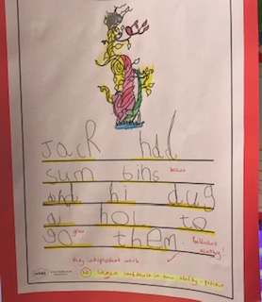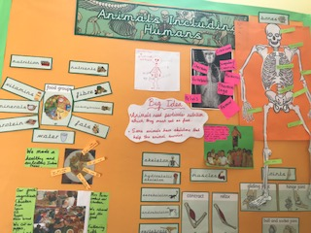

Year 4 were very excited today as they went to London to visit the Sea Life Centre – I waved off a coach of very happy children (and adults!) Year 5 visited the Heritage Centre as part of their Victorian topic – they looked very authentic in their Victorian costumes and had their nails inspected as they entered the school. Year 6 have been very busy rehearsing their play – I have enjoyed listening to the singing drifting along the corridor!

Thank you for your continued support – have a lovely weekend

Fiona Crascall
Headteacher

Sign of the week

Church

Attendance
Class | %
Robins – year 1 | 97.73
Magpies – year 2 | 98.21
Owls – year 3 | 93.89
Hawks – year 4 | 97.50
Eagles – year 5 | 94.81
Falcons year 6 | 100
Please make sure that you either fill the child collection book in during the morning or ring the school before 12 if somebody else is collecting your child – it interrupts learning in the afternoon if we have to ring down to classes. Thank you for your support.

Dates for your diary
Terms 4 and 5
Monday 15th July | Internet Legends e-safety assembly
Tuesday 16th July | Year 6 production dress rehearsal to school
Wednesday 17th July | Year 6 production to parents at 1.45pm in the school hall
Thursday 18th July | PTFA Summer Disco
Friday 19th July | Year 6 production to parents at 5.30pm in the school hall
Monday 22nd July | End of term 6 – Leavers Service at 1.45 – then back to school for the year 6 children to proceed out of the front entrance
September 2019
2nd & 3rd September | Staff Development Days
4th September | Children return to school.
6th January 2020 | Staff Development Day
1st April 2020 | Staff Development Day
22nd July2020 | Last Staff Development Day

PTFA Update

Don't forget Frozen Friday today!

The Summer Disco is on Thursday 18th July after school! Please refer to letters sent home last week for full information. If your child is in KS1 please return the form and payment by this Monday. KS2 children can pay on the night. Children can bring spending money if they would like to buy any novelties (glow sticks etc). Prices start from 20p.

.

