Schools must use the funding to make additional and sustainable improvements to the quality of PE and sport they offer. This means that you should use the Primary PE and Sport Premium to:

- develop or add to the PE and sport activities that your school already offers
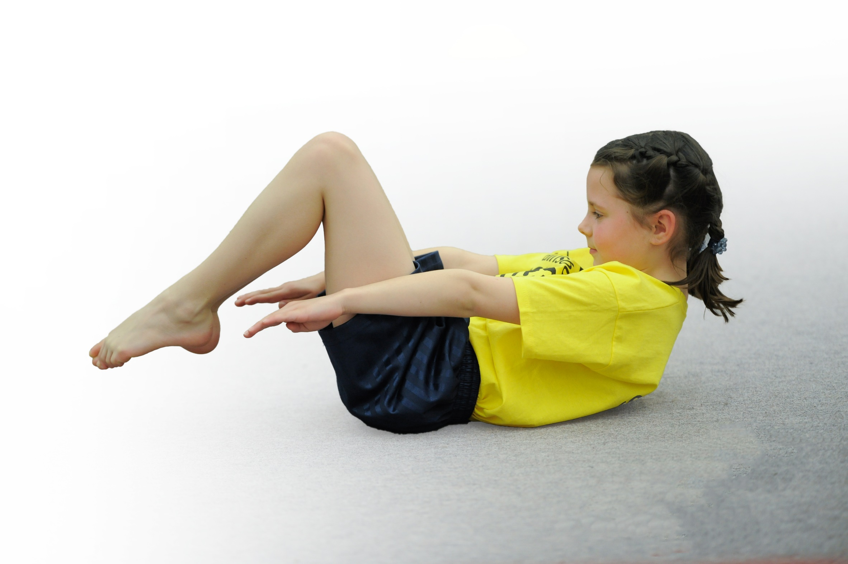
- build capacity and capability within the school to ensure that improvements made now will benefit pupils joining the school in future years

Please visit gov.uk for the revised DfE guidance including the 5 key indicators across which schools should demonstrate an improvement. This document will help you to review your provision and to report your spend. DfE encourages schools to use this template as an effective way of meeting the reporting requirements of the Primary PE and Sport Premium.

We recommend you start by reflecting on the impact of current provision and reviewing the previous spend.
Under the Ofsted Schools Inspection Framework, inspectors will assess how effectively leaders use
the Primary PE and Sport Premium and measure its impact on outcomes for pupils, and how effectively governors hold them to account
for this.

Schools are required to publish details of how they spend this funding as well as on the impact it has on pupils’ PE
and sport participation and attainment.
We recommend regularly updating the table and
publishing it on your website as evidence
of your ongoing review into how you are using the money
to secure maximum, sustainable impact. To see an example of how to complete the table please click HERE.

Support for review and reflection - considering the 5 key indicators from DfE, what development needs are a priority for your setting and your students now and why? Use the space below to reflect on previous spend, identify current need and priorities for the future.

Key achievements to date: | Areas for further improvement and baseline evidence of need:
- Maintained pupil participation in school games – continued GOLD award.  - Designed, planned, organised and implemented the new ‘School Hub Termly Tournament’ at Duke of York Royal Military school’. Hub events based on sports not previously available.  - Introduced a variety of new sports and activities to encourage more pupils to take up sport/physical activities. Namely, Lacrosse, Danish Long Ball and Boccia.  - Ran a yearly ‘Sports Week’ to inspire and provide opportunities to participate in new sports.  - Developed a working ‘Sports Squad’ for playtimes and event support creating young leaders.  - Regular and effective swimming opportunities across KS2.  Developed the PE long term plan further and reviewed the assessment system  - Employed specialist teacher to work alongside and upskill staff.  - Established the daily mile for pupils.  - Ensured fair opportunities for pupil premium children to participate in events.  - Implemented the house teams across the school to promote character education, belonging and pupil leadership.  - Installed concrete basketball hoops on the school playground  - Installed an all-weather MUGA pitch on the school grounds  - Installed a climbing wall on the school grounds to encourage pupil agility and ‘active play’  - Playground marking updated to encourage active break times ie four square courts | - Embed pupils confidence to take on leadership roles, that support physical activity in school i.e sports squad, house captains and KS2 running events for KS1.  - Add 2 further sports to the curriculum.  - Increase ‘intra-school competition’ throughout the year.  - Enhance the ‘Active play’ at break times.  - Long-Term goal of School Games Platinum.  - Use MOKI more effectively across KS2  - Implement House intra-competitions across different subjects  - Renewing playground markings in EYFS and Year 1 classroom areas to inspire active play.

Meeting national curriculum requirements for swimming and water safety
What percentage of your current Year 6 cohort swim competently, confidently and proficiently over a distance of at least 25 metres? | 72%
What percentage of your current Year 6 cohort use a range of strokes effectively [for example, front crawl, backstroke and breaststroke]? | 52%
What percentage of your current Year 6 cohort perform safe self-rescue in different water-based situations? | 60%
Schools can choose to use the Primary PE and Sport Premium to provide additional provision for swimming but this must be for activity over and above the national curriculum requirements. Have you used it in this way? | Yes/No
*Schools may wish to provide this information in April, just before the publication deadline.

Action Plan and Budget Tracking
Capture your intended annual spend against the 5 key indicators. Clarify the success criteria and evidence of impact that you intend to measure to evaluate for students today and for the future.

Academic Year: 2023/24 | Total fund allocated: £17,130 | Date Updated: April 2023
Key indicator 1: The engagement of all pupils in regular physical activity – Chief Medical Officer guidelines recommend that primary school children undertake at least 30 minutes of physical activity a day in school |  |  |  | Percentage of total allocation:
 |  |  |  | 26%
School focus with clarity on intended impact on pupils: | Actions to achieve: | Funding allocated: | Evidence and impact: | Sustainability and suggested next steps:
- Daily mile and 5 minute HIITS across KS1 and KS2 to improve physical activity  - Enhance active play on the playground at break and lunch  - KS2 Children to wear electronic devices (Moki) to track number of steps in school 1 week a term.  - Source new playground equipment ie new playtime equipment. | - PE leader to ensure teachers complete daily sessions  - PE leader monitors use of daily mile. Develop varied opportunities to keep this interesting (House point competitions)  - PE leader set up sports squad to champion lunchtime clubs.  - PE leader to source relevant devices | PE leader support £3000  N/A  Already purchased  £1380 | - Pupils participating ‘The Daily Mile’ each day.  - Children leading PE, clubs, events and lunchtime activities. – improved fitness/behaviour  - 100% PE participation.  - Pupil Voice to support next steps. | Train and Plan breaktime and lunchtime active play.  Pupil Voice to support next steps.  Schedule Intra-school competitions.
Key indicator 2: The profile of PE and sport being raised across the school as a tool for whole school improvement |  |  |  | Percentage of total allocation:
 |  |  |  | 14%
School focus with clarity on intended impact on pupils: | Actions to achieve: | Funding allocated: | Evidence and impact: | Sustainability and suggested next steps:
- Continue to offer a variety of different sports to embed the wider curriculum  - Celebrate competitions and successes on weekly newsletter, in worship and through the house cup systems.  - Build upon Hub competition this year, inviting new members and building relationships with outside agencies  - Provide further sporting opportunities to Year 3/4. | - Increase the variety of resources available – opportunities for new sports  - Ensure profile of PE is raised through school comms - Sports Squad to lead. Write review for the newsletter/website.  Social media use.  - Work with HUB and other local schools to share expertise and external opportunities for children. Enhance this years Hub cup competitions from 4 to 6 events. Invite further members. | £1500  N/A  Release time for meetings £800 | - PE has a high profile across the school and improves pupil outcomes  - Children take a pride in their sporting achievements  - HUB support ensures that the profile of PE is high and supports a broad and balanced curriculum, while adding further competition. | Sport is seen as important across the school and links in with our mission statement ‘Through God’s love and strength all flourish’.  Parents and pupils are made aware of competitions and success

Key indicator 3: Increased confidence, knowledge and skills of all staff in teaching PE and sport |  |  |  | Percentage of total allocation:
 |  |  |  | 27%
School focus with clarity on intended  impact on pupils: | Actions to achieve: | Funding  allocated: | Evidence and impact: | Sustainability and suggested  next steps:
- PE leader to observe and support teaching and learning – work alongside new teachers to upskill planning and delivery (focus on ECT’s)  - PE leader to support staff in PE assessment to ensure progression of skills.  - PE leader to use staff meeting time to enhance sporting knowledge.  - Staff to use PPA time to ‘team teach’ with the PE leader.  - PE Leader to attend PE Conference and deep dive training. | - Clear timetable for regular observation, feedback and follow up – staff to observe PE leader  - PE leader to work alongside staff to accurately assess pupil progress and skills  - PE leader to lead staff meetings and upskill staff based on Staff survey. | £3500 PE leader salary  Cover £1000 | - Lessons observations show that PE lessons are skillfully taught and staff are confident when teaching  - Assessment shows improvement from Term 1 to Term 6  - Staff meetings upskill teacher knowledge to improve PE teaching across the school – Staff survey/observations. | Ensure that staff are competent to deliver high quality PE and sporting lessons and have the resources to back this up. Training ensures teachers are confident to teach a variety of PE lessons
Key indicator 4: Broader experience of a range of sports and activities offered to all pupils |  |  |  | Percentage of total allocation:
 |  |  |  | 14%
School focus with clarity on intended  impact on pupils: | Actions to achieve: | Funding  allocated: | Evidence and impact: | Sustainability and suggested  next steps:
- Long term plan offering a broad range of sports and activities  - Expectation that all staff will lead a club  - Sports events across all key stages, incorporating all abilities, in a variety of sports.  - Hub events based on sports not previously available.  - Intra sport competition based on a new sport.  - Ensure sports week includes varied sports to inspire participation and offer outside school opportunities.  - Ensure future spending incorporates a focus on swimming (April 2023)  - School to fund extra resources for the MUGA to give other options rather than football | - PE leader will ensure progression and variety on long term plan  - Pupil voice to guide clubs led by staff  - Broaden links with other agencies and intra school competitions  - PE leader to invite guests/athletes/local companies to enrich sports week.  - Look at options to ensure quality swimming lessons that provide value for money  - Increase competitive opportunities.  - HT and PE leader to source quotes and funding further active play opportunities. | £800  N/A  Travel £150  Supporting events £1000  £500  £200 for equipment to ensure this is used effectively | - Long term plan monitored by HT and Govs.  - Pupil voice shows wide range of sports clubs  - Attendance at a wide range of events – all pupils participating - Evidenced  - Successful planning and execution of sports week  - Swimming available for Years 4-6 yearly.  - Children have access to a range of activities in all weathers | Pupil premium children are not disadvantaged and attend a range of sports and activities. School builds upon successes and builds upon broad PE curriculum  Enhanced sports facilities raise the profile of PE within the school and broaden the range of sports activities offered
Key indicator 5: Increased participation in competitive sport |  |  |  | Percentage of total allocation:
 |  |  |  | 19%
School focus with clarity on intended  impact on pupils: | Actions to achieve: | Funding  allocated: | Evidence and impact: | Sustainability and suggested  next steps:
- Continue to attend events with other schools via ‘The HUB schools and Dover School Games, alongside local friendlies.  - Encourage non-evasive competitions during PE lessons.  - Liaise with Dover school games to ensure we continue to attend a variety of competitive sports, including swimming  - Increase ‘Intra-Sport Competition’, linking to our houses. | - Build upon successes of this year and strengthen links with other schools  - Build competitions into long and medium term plans  - Ensure sports week incorporates a range of competitive sport – to include water safety | Travel/petrol/release time £2200  Resources £500  Event costs £500 | - Children take part in a variety of events across Kent and enjoy sport  - Pupil voice shows pupils are positive about sport – PE lessons provide a variety of competitions  - School attendance at swimming gala, Dover school game competitions, infant agility and handball | Log of events attended increases and the school has a high profile at competitive events – becomes part of the ‘daily diet’ of pupils

