Schools must use the funding to make additional and sustainable improvements to the quality of PE and sport they offer. This means that you should use the Primary PE and Sport Premium to:

- develop or add to the PE and sport activities that your school already offers
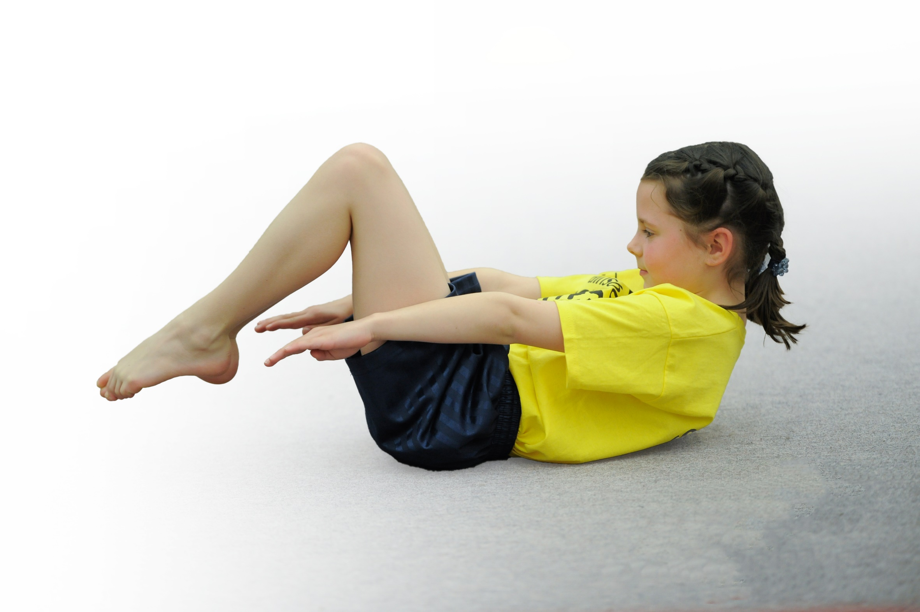
- build capacity and capability within the school to ensure that improvements made now will benefit pupils joining the school in future years

Please visit gov.uk for the revised DfE guidance including the 5 key indicators across which schools should demonstrate an improvement. This document will help you to review your provision and to report your spend. DfE encourages schools to use this template as an effective way of meeting the reporting requirements of the Primary PE and Sport Premium.

We recommend you start by reflecting on the impact of current provision and reviewing the previous spend.
Under the Ofsted Schools Inspection Framework, inspectors will assess how effectively leaders use
the Primary PE and Sport Premium and measure its impact on outcomes for pupils, and how effectively governors hold them to account
for this.

Schools are required to publish details of how they spend this funding as well as on the impact it has on pupils’ PE
and sport participation and attainment.
We recommend regularly updating the table and
publishing it on your website as evidence
of your ongoing review into how you are using the money
to secure maximum, sustainable impact. To see an example of how to complete the table please click HERE.

Support for review and reflection - considering the 5 key indicators from DfE, what development needs are a priority for your setting and your students now and why? Use the space below to reflect on previous spend, identify current need and priorities for the future.

Key achievements to date: | Areas for further improvement and baseline evidence of need:
- Increased pupil participation in school games  - Partnered with other local schools to compete in clubs and activities  - Introduced a variety of new sports and activities to encourage more pupils to take up sport/physical activities  - Introduced new PE long term plan and assessment system  - Employed specialist HLTA to work alongside and upskill staff  - Ensure fair opportunities for pupil premium children to participate in events | - Provide additional opportunities for children to participate in games  - Encourage pupils to take on leadership roles, that support physical activity in school ie sports squad  - Embed physical activity into the school day ie active travel, active playground and active teaching

Meeting national curriculum requirements for swimming and water safety | Please complete all of the below*:
What percentage of your current Year 6 cohort swim competently, confidently and proficiently over a distance of at least 25 metres? | 80%
What percentage of your current Year 6 cohort use a range of strokes effectively [for example, front crawl, backstroke and breaststroke]? | 70%
What percentage of your current Year 6 cohort perform safe self-rescue in different water-based situations? | 35%
Schools can choose to use the Primary PE and Sport Premium to provide additional provision for swimming but this must be for activity over and above the national curriculum requirements. Have you used it in this way? | Yes/No
*Schools may wish to provide this information in April, just before the publication deadline.

Action Plan and Budget Tracking
Capture your intended annual spend against the 5 key indicators. Clarify the success criteria and evidence of impact that you intend to measure to evaluate for students today and for the future.

Academic Year: 2019/20 | Total fund allocated: £ | Date Updated:
Key indicator 1: The engagement of all pupils in regular physical activity – Chief Medical Officer guidelines recommend that primary school children undertake at least 30 minutes of physical activity a day in school |  |  |  | Percentage of total allocation:
 |  |  |  | 22%
School focus with clarity on intended impact on pupils: | Actions to achieve: | Funding allocated: | Evidence and impact: | Sustainability and suggested next steps:
- Build a bank of videos produced by the children to encourage 30 minutes physical activity  - Introduce wake up and shake up in KS1 to improve physical activity  - Daily mile and 5 minute HIITS in KS2 to improve physical activity  - Introduce and active ‘to and from’ school scheme to improve physical activity | - PE leader to ensure children design their own fitness videos to use within the school  - PE leader monitors use of daily mile  - PE leader set up sports squad to champion lunchtime clubs  - Work with parent council to collate ideas ie walk on Wednesday | HLTA leader support £3000  N/A  HLTA time £500  £400 | - Selection of videos that are unique to our school  - Pupils participating wake up and shake up daily – improved fitness  - KS2 completing daily mile – improved fitness  - Children leading PE – improved fitness  - Children more active – increased fitness | Physical activity occurs regularly outside of PE lessons and becomes part of the school culture
Key indicator 2: The profile of PE and sport being raised across the school as a tool for whole school improvement |  |  |  | Percentage of total allocation:
 |  |  |  | 19%
School focus with clarity on intended impact on pupils: | Actions to achieve: | Funding allocated: | Evidence and impact: | Sustainability and suggested next steps:
- Start to work towards the School Games Mark (bronze or silver)  - Continue to offer a variety of different sports to embed the wider curriculum  - Jumpers and hoodies for sports squad  - Celebrate competitions and successes on weekly newsletter and in worship  - Build upon collaborations to ensure increased profile of PE | - Register and apply and provide proof that guidelines are adhered to  - Increase the variety of resources available – opportunities for new sports  - Purchased for the pupils and pupils trained  - Ensure profile of PE is raised through school comms  - Work with HUB and other local schools to share expertise and external opportunities for children | Release time £600  £2000  N/A  £100  Release time for meetings £800 | - Raises the profile of PE in the school and wider community – recognition of impact of PE leader  - PE has a high profile across the school and improves pupil outcomes  - Children take a pride in their sporting achievements  - HUB support ensures that the profile of PE is high and supports a broad and balanced curriculum | Sport is seen as important across the school and links in with our vision statements ‘all to be the very best that God intended’. Parents and pupils are made aware of competitions and success

Key indicator 3: Increased confidence, knowledge and skills of all staff in teaching PE and sport |  |  |  | Percentage of total allocation:
 |  |  |  | 29%
School focus with clarity on intended  impact on pupils: | Actions to achieve: | Funding  allocated: | Evidence and impact: | Sustainability and suggested  next steps:
- PE leader to observe and support teaching and learning – work alongside teachers to upskill planning and delivery  - PE leader to support staff in PE assessment to ensure progression of skills  - PE leader to use staff meeting time to enhance sporting knowledge | - Clear timetable for regular observation, feedback and follow up – staff to observe PE leader  - PE leader to work alongside staff to accurately assess pupil progress and skills  - PE leader to lead termly staff meetings and upskill staff | £3000 HLTA salary  Cover £1000  HLTA overtime £1200 | - Lessons observations show that PE lessons are skillfully taught and staff are confident when teaching  - Planning shows a wide range of skills being taught as part of a broader curriculum  - Staff meetings upskill teacher knowledge to improve PE teaching across the school | HLTA ensures that staff are competent to deliver high quality PE and sporting lessons. Training ensures teachers are confident to teach a variety of PE lessons
Key indicator 4: Broader experience of a range of sports and activities offered to all pupils |  |  |  | Percentage of total allocation:
 |  |  |  | 15%
School focus with clarity on intended  impact on pupils: | Actions to achieve: | Funding  allocated: | Evidence and impact: | Sustainability and suggested  next steps:
- Evaluating long term plan to ensure a broad range of sports and activities  - Expectation that all staff will lead a sports club  - Sports events across all key stages, incorporating all abilities, in a variety of sports  - Raise funds for a school minibus so we can attend a range of local sporting events  - Ensure sports week includes visits from external agencies and other specialists  - Ensure future spending incorporates a focus on swimming (April 2020) | - PE leader will ensure progression and variety on long term plan  - Pupil voice to guide clubs led by staff  - Broaden links with other agencies and intra school competitions  - PE leader to invite quests/athletes/local companies to enrich sports week  - Look at options to ensure quality swimming lessons that provide value for money | N/A  N/A  Travel £150  Supporting events £1000  Minibus £1000  £300 | - Long term plan monitored by HT and Govs.  - Pupil voice shows wide range of sports clubs  - Attendance at a wide range of events – all pupils participating  - Successful planning and execution of sports week  - Swimming available for KS2 from April 2020 | Pupil premium children are not disadvantaged and attend a range of sports and activities. School builds upon successes and builds upon broad PE curriculum
Key indicator 5: Increased participation in competitive sport |  |  |  | Percentage of total allocation:
 |  |  |  | 15%
School focus with clarity on intended  impact on pupils: | Actions to achieve: | Funding  allocated: | Evidence and impact: | Sustainability and suggested  next steps:
- Continue to attend events with other schools ie football matches, netball matches, handball and cricket  - Encourage non-evasive competitions during PE lessons  - Liaise with Dover school games to ensure we continue to attend a variety of competitive sports | - Build upon successes of this year and strengthen links with other schools  - Build competitions into long and medium term plans  - Ensure sports week incorporates a range of competitive sport | Travel/petrol/release time £2000  Resources £500  Event costs £200 | - Children take part in a variety of events across Kent and enjoy sport  - Pupil voice shows pupils are positive about sport – PE lessons provide a variety of competitions  - School attendance at swimming gala, Dover school game competitions, infant agility and handball | Log of events attended increases and the school has a high profile at competitive events – becomes part of the ‘daily diet’of pupils

