In **Literacy** this term we will be looking at researching the lives of the Tudors: their Kings and Queens, Henry VIII and his wives and life in Tudor times. We shall write biographies, recipes, diaries and letters.

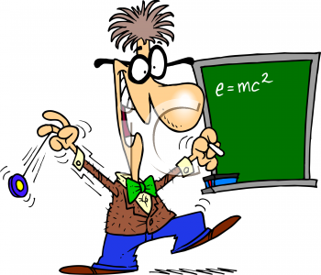

In **Maths** in we are going to be revisiting written skills and calculations then working on, adding, subtracting, multipliying and dividing fractions, reasoning and problem solving. The popular Times Tables Challenge will continue – ALL the children are getting more fluent in their knowledge of times tables which is essential for accessing the Y5 Maths curriculum! If your child does not yet know all their times tables, encourage them to practise little and often using sites such as: <https://www.topmarks.co.uk/maths-games/hit-the-button>

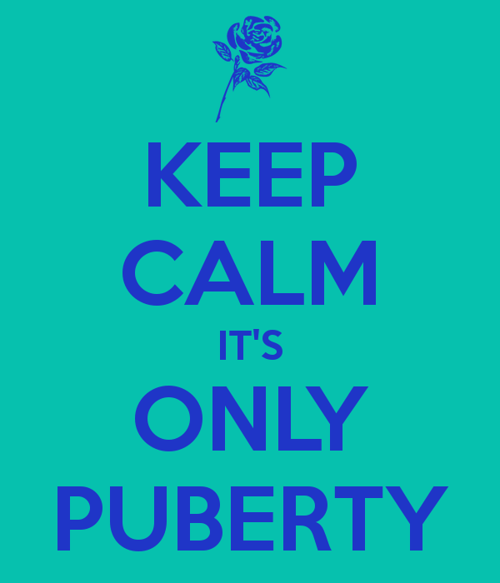

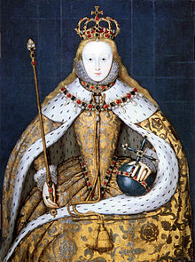

**Eagles Class Newsletter**

**Term 4**

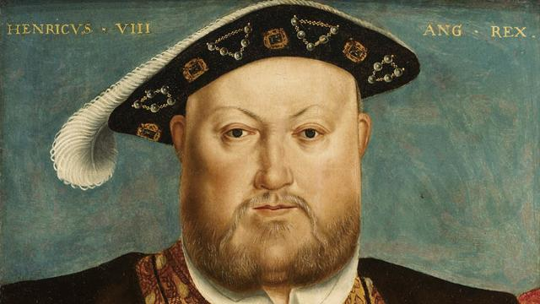

Our **Science** this term is “Animals including Humans”. This topic covers the Human timeline, the growth of babies, puberty and how humans change into old age. If you have any questions about the details of this unit of work please come and see me or contact me via email/phone. It would be useful for you to have a chat with your child about puberty before we cover this in class so there are no shocks! Also your child may have some questions for you at home!

**Homework**: The learning grid is going home this week with a variety of tasks to choose from. If your child is struggling with any of the homework then please let me know or write a note in their learning journal. Please listen to your child read and discuss their book with them at least a couple of times a week – this does have a direct effect on the reading age and comprehension ability of your child!

**P.E.** Please ensure **all** PE kits are in school as of this week – as usual the class will have Mr. Hayes for PE on Tuesday and Wednesday afternoons.

**Wembley Trip** : Thurs 21st March – more details to go home soon!

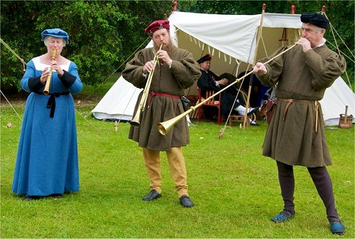

Welcome to Term 4!

How the year is flying by! Term 4 will once again be a short one but there is plenty to pack in.

Our topic this term is “Horrible Histories – The Terrible Tudors”. We will be learning about when the Tudors lived, how religion changed under Henry VIII, their Kings and Queens, their buildings, food, art and stories.

Spelling, punctuation and grammar (SPaG) lessons will be looking at the objectives of: writing in first person to build tension, converting text from past to present tense, all the uses of the comma, editing punctuation errors and determiners. Our daily 20 minute spelling sessions will look at different spelling patterns, rules and conventions.

http://www.pavendors.com/images/smileyface.gif

As always – if you have any worries or concerns about your child please phone, visit or send in a note.

Miss S Graham