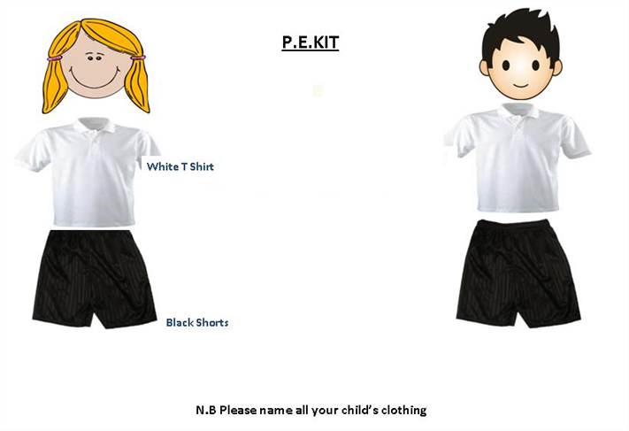

As always – if you have any worries or concerns about your child please phone, visit or send in a note. Miss Graham

Ms S Muddle

Our Science this term is “Properties and changes of Materials”. The class will be investigating the different properties of materials, separating mixtures and reversible/irreversible changes.

Our **SPaG** (spelling grammar and punctuation) continues from last year now working on the Y5 curriculum. In **Maths** we are going to be revisiting basic skills and Place Value, then working on addition, subtraction, division and multiplication. The popular weekly Times tables challenge has already begun and the children are challenging themselves to improve by half term!

Times tables are key to being able to access the Y5 Maths curriculum, so any extra practise completed at home will be extremely useful!

**Tuesday and Wednesday**

On Tuesday afternoons and all day Wednesdays Mr Hayes teaches Eagles class. He will be teaching PE on both of these afternoons so please ensure your child has appropriate PE clothing for those days.

**Homework** will go home shortly and be the same format as in the rest of the school where various tasks can be chosen from a grid of suggestions. The children have pink books in which they can record their homework in, however there are options to make models/posters etc which they will want to make separately.

Times tables are ongoing – when you are in the car give your child a quick quiz or chant a table with them. If your child is struggling with any of the homework then please let me know or write a note in their reading record book.

Please **read** as often as possible with your child at home – the more they read the better they read !

**Welcome** to the new school year in Eagles Class! We have started the year well by getting settled into our new routines including new Maths and Spelling groups. The first few weeks are all about getting to grips with where the children are in Maths and Literacy. The children may well find that they move groups after a couple of weeks, or work in different groups during the week depending on what support or challenge they need.

Our topic this term is “Around the World in 80 days” which will involve looking at the varied countries and climates around the world, and with a focus on South Africa. It will be a Geography based topic and we will learn about the geography of the planet including where the Equator, tropics and polar regions are. Within Literacy we will work on a ‘big write’ which will involve the children developing their character description and scene setting writing skills.

**Eagles Class Newsletter**

**Term 1 2018**